**ETL Implementation through Pentaho**

**Starting with Pentahoo**

**Step 1.** Open Data Integration folder (C:\data-integration)

**Step 2.** Double click on spoon(Windows Batch file)

**Step 3.** Click on cancel

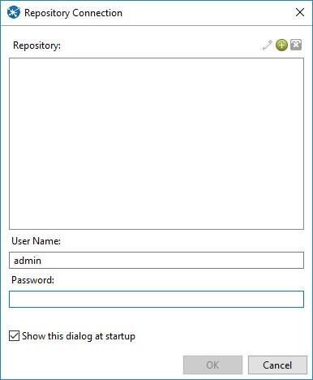

**1. Transforming Source Table and storing to Output Table in SQL**

**Step1: Go to Pentaho**

**Step2: Go to file->New->Transformation.**

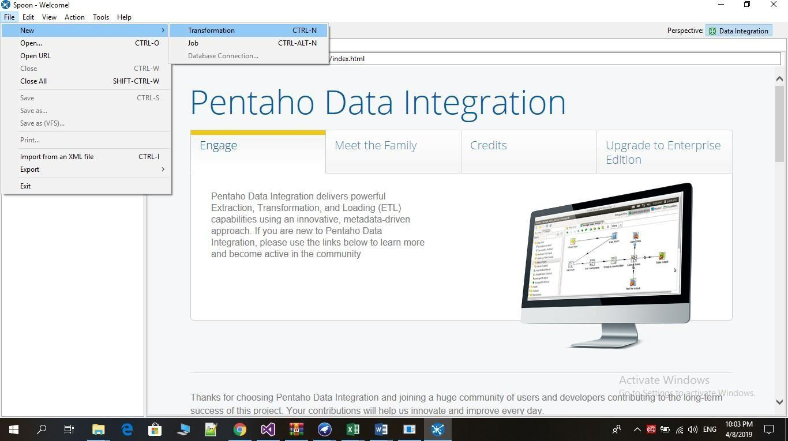

**Step 3: Click on Input**

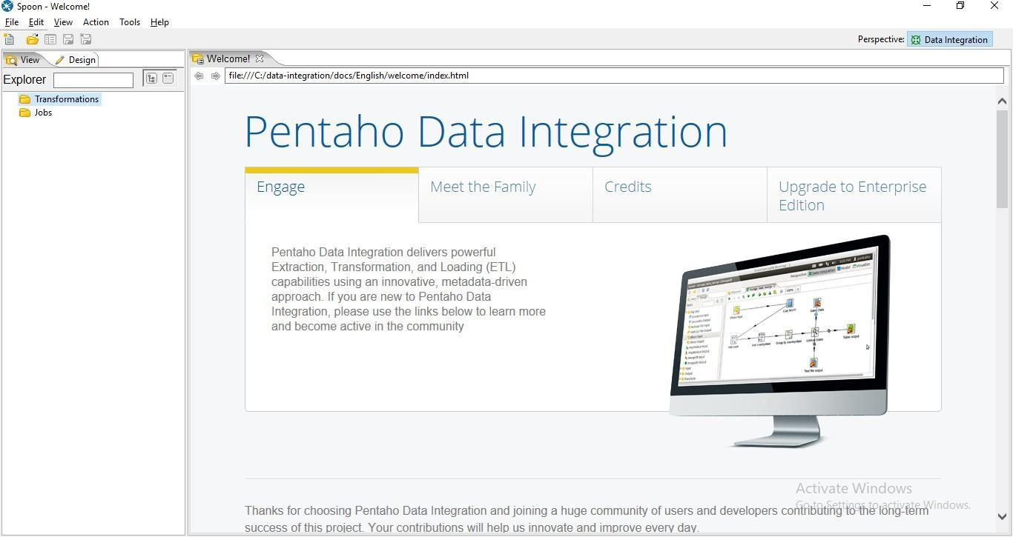

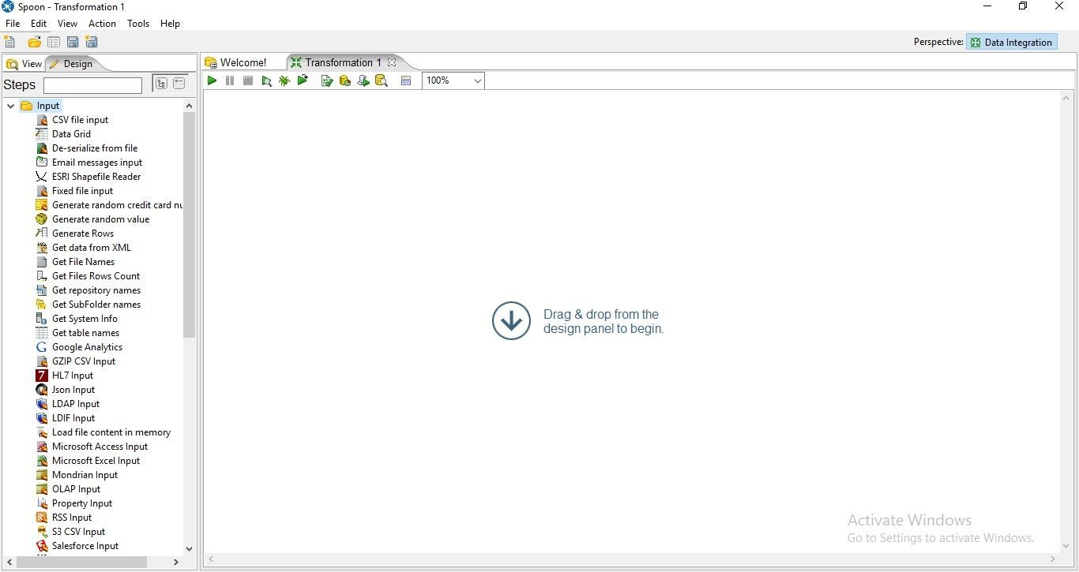

**Step 4: Drag Table Input on the panel**

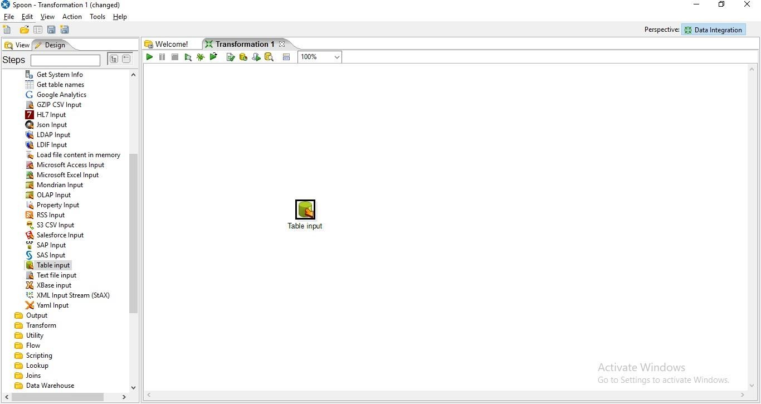

**Step 5: Double Click on Table Input and the following tab will appear.**

1. **Click On New**

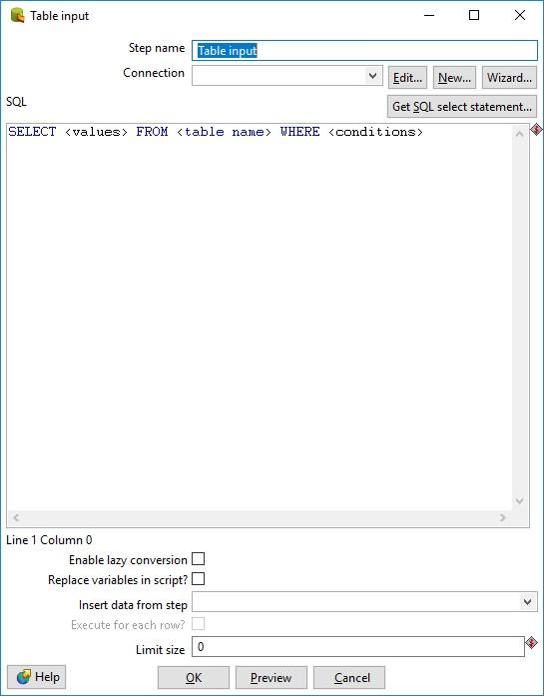

1. **Select Oracle in Connection Type and enter Connection Name, Database Name, User Name and Password and click on Test.**

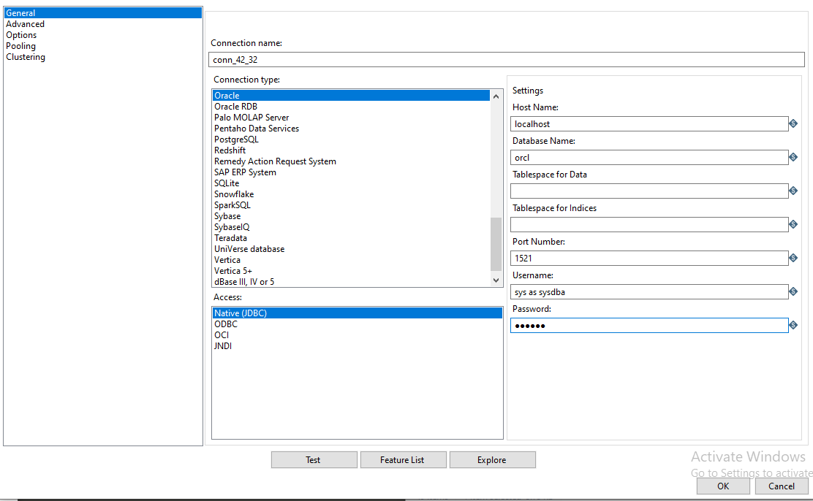

**Connection Successful**

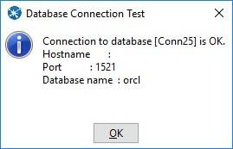

1. **Click on get SQL select statement**

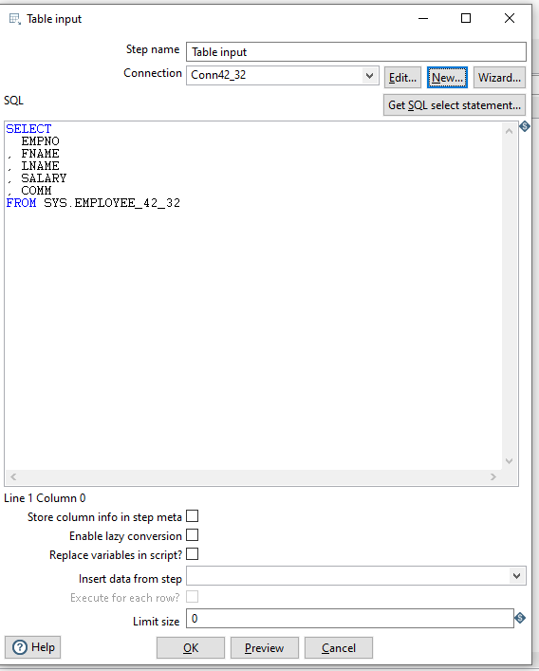

**Click on database -> table and select the table name.**

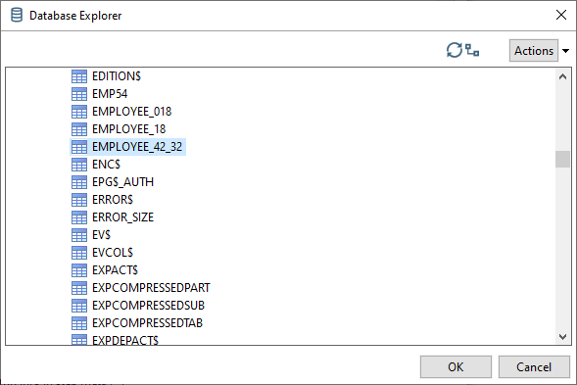

1. **Click on Preview**

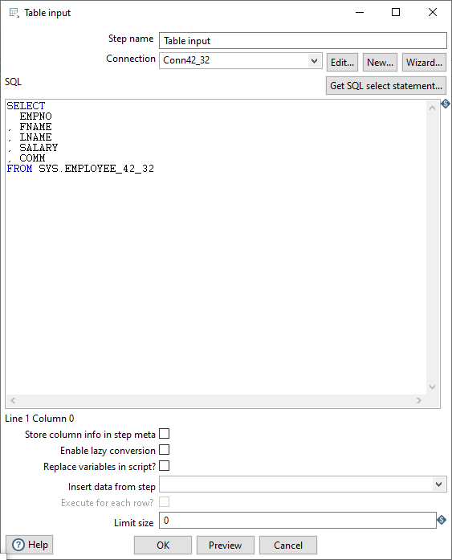

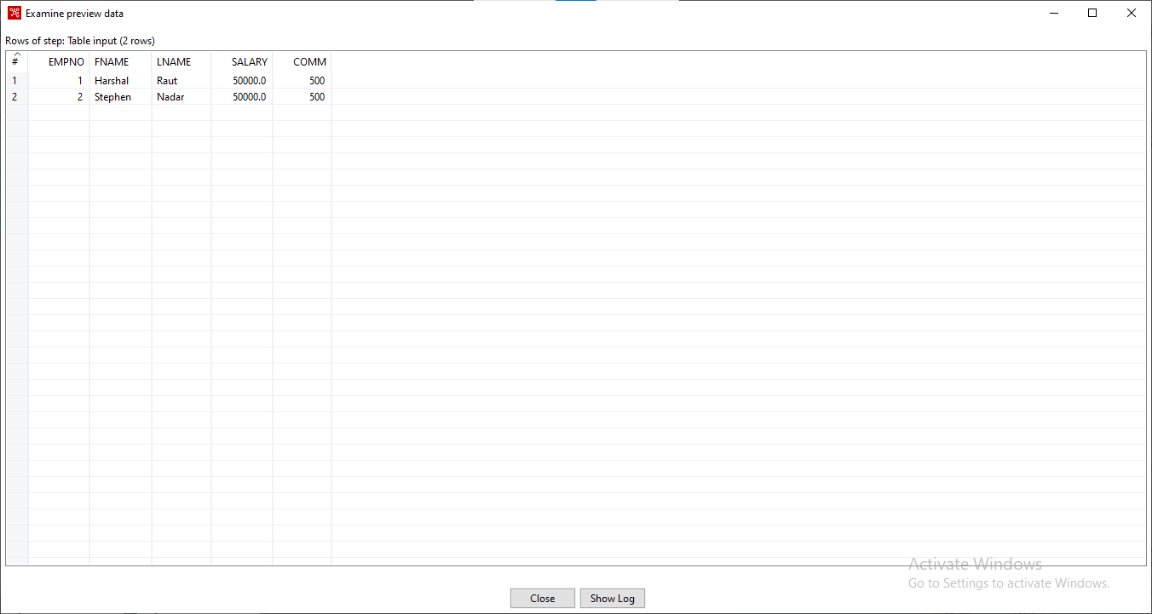

**Step 6: Click on Output and drag table Output.**

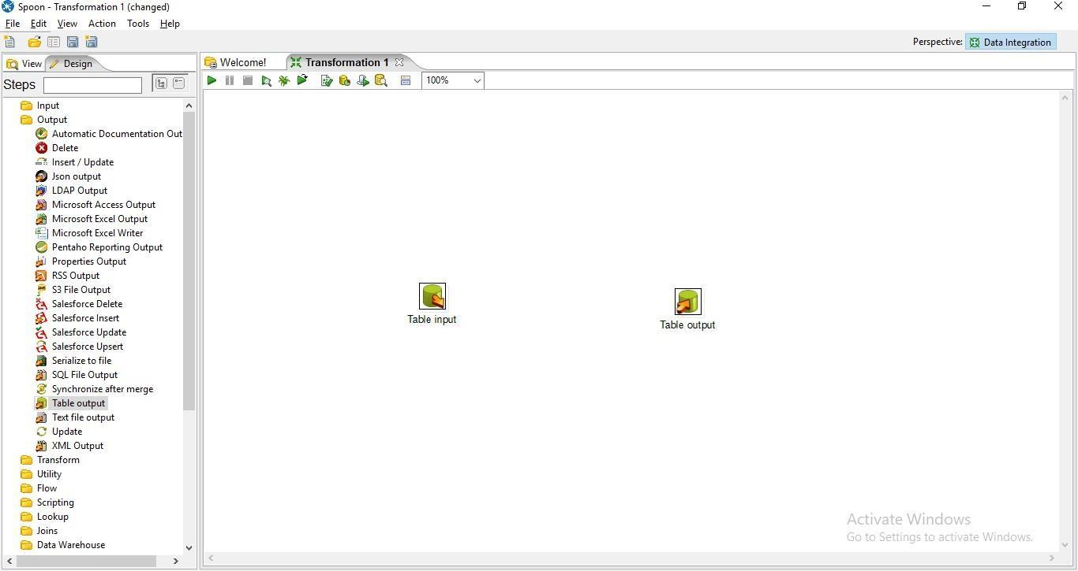

**Step 7: Hold the mouse Pointer on table input and select and drag the Output connector to the Table output.**

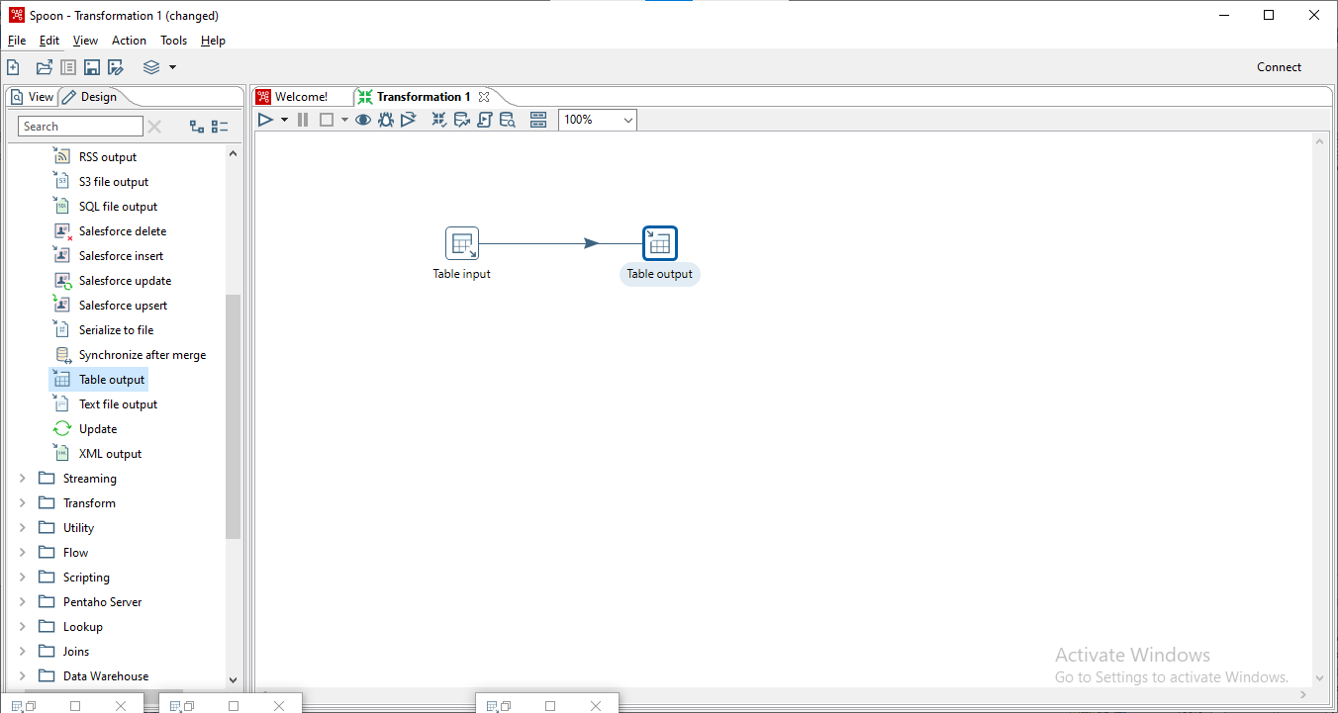

**Step 8: Double Click on target table**

1. **Enter the Target table name and check the truncate table and Specify database fields Check Box**

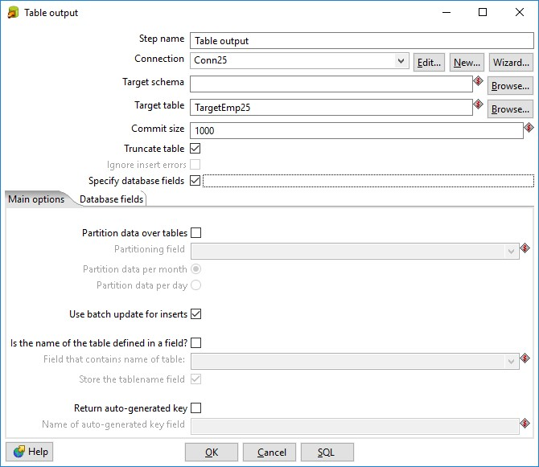

1. **Click On Database fields and click on Get fields.**

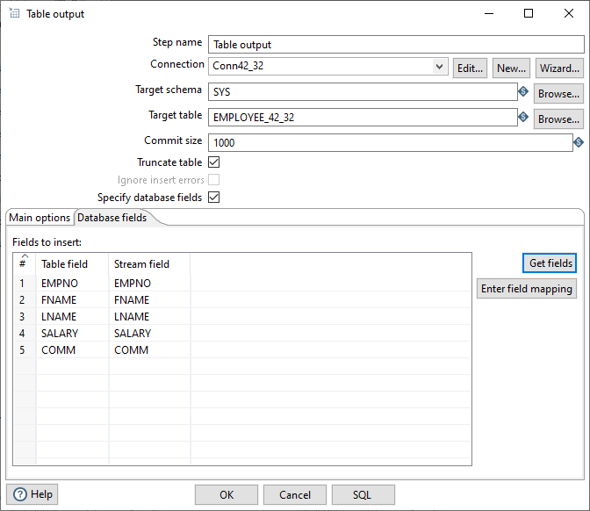

1. **Click on SQL and click on Execute.**

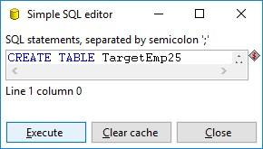

1. **Click Ok**

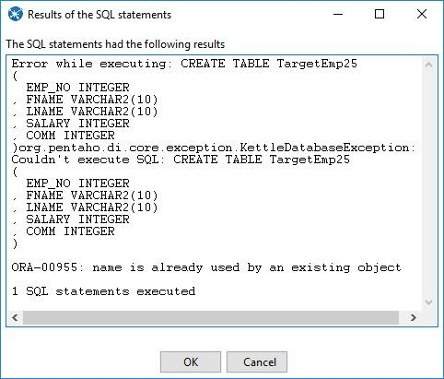

**Step 9: Click on Run Transformation and Click on Launch**

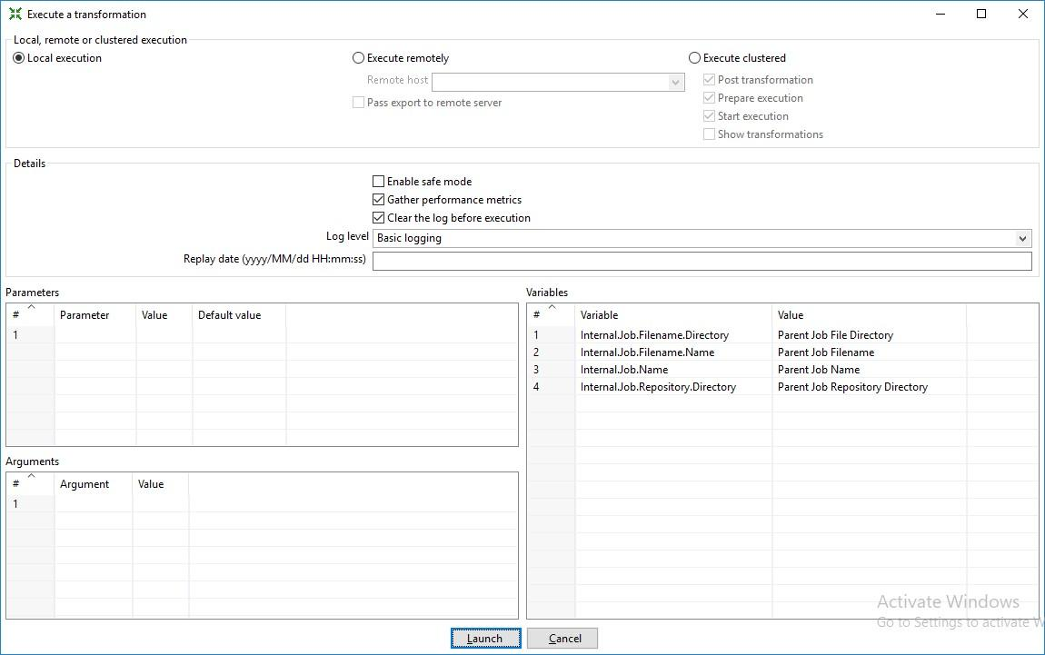

**Step 10: Click on Debug Transformation(Spider) and Click on Quick Launch**

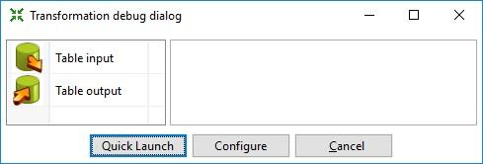

**Output:**

**The Green ticks on the table input and table output shows successful transformation.**

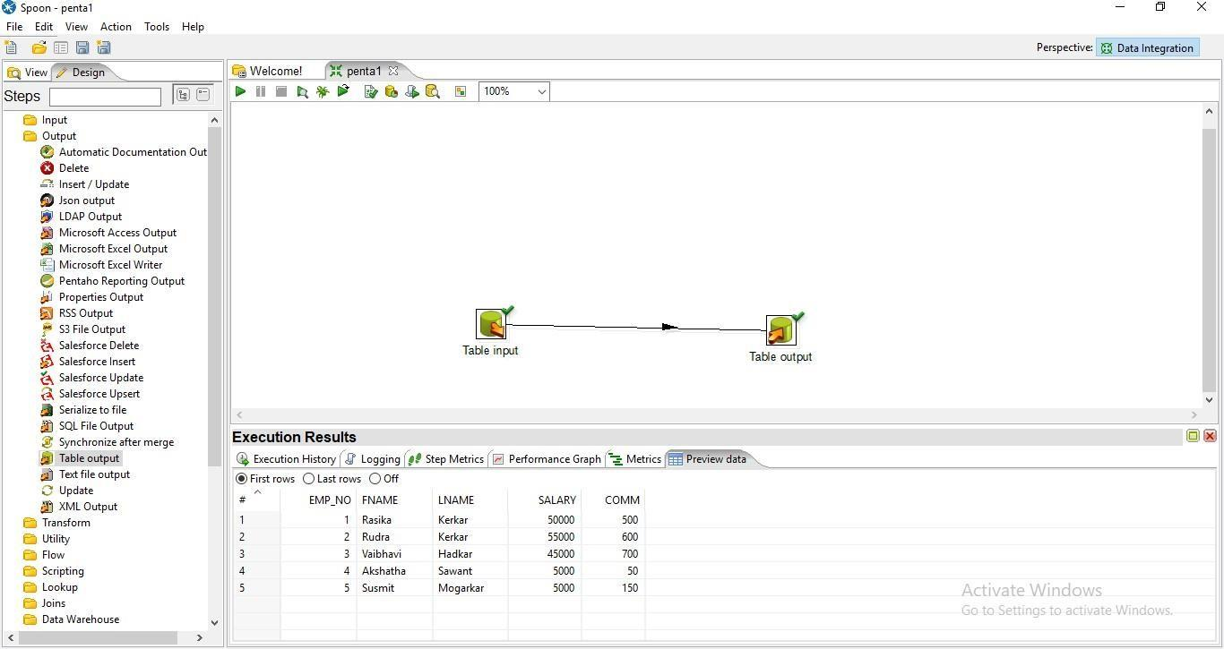

**2. Sorting Operation and adding Sequence to Output Table.**

**Step 1: Perform the first 5 steps same as practical 1.**

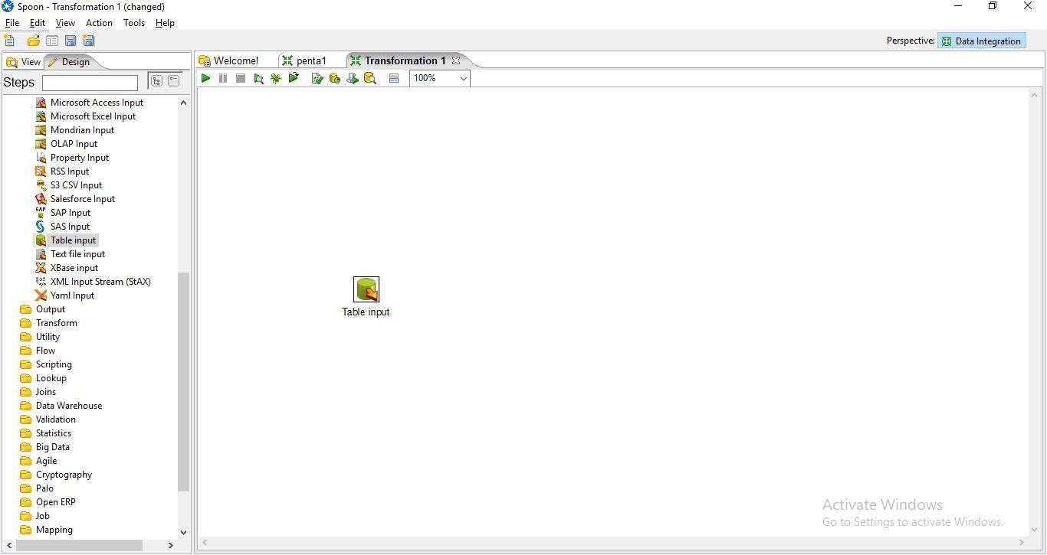

**Step 2: Click on Transform in the left**

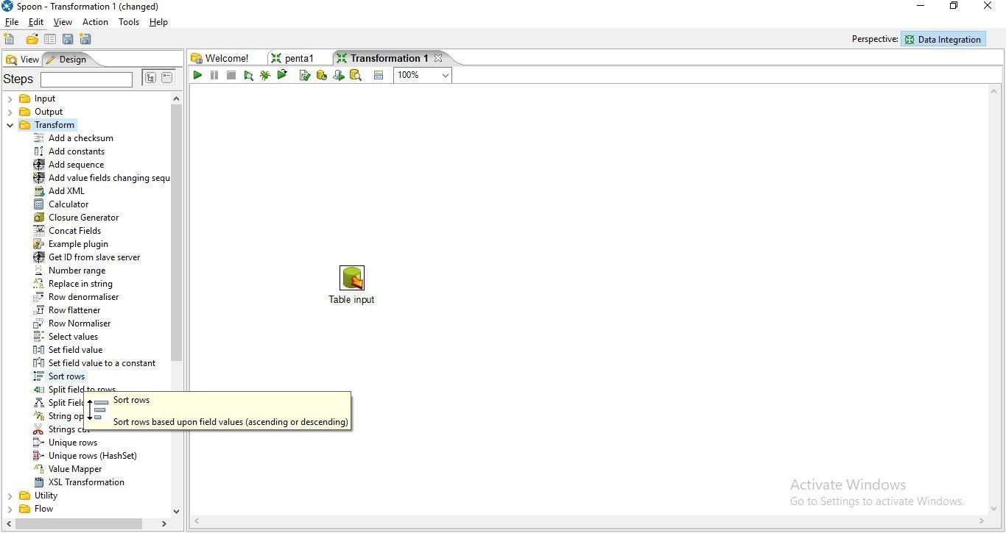

**Step 3: Drag sort rows on the Panel**

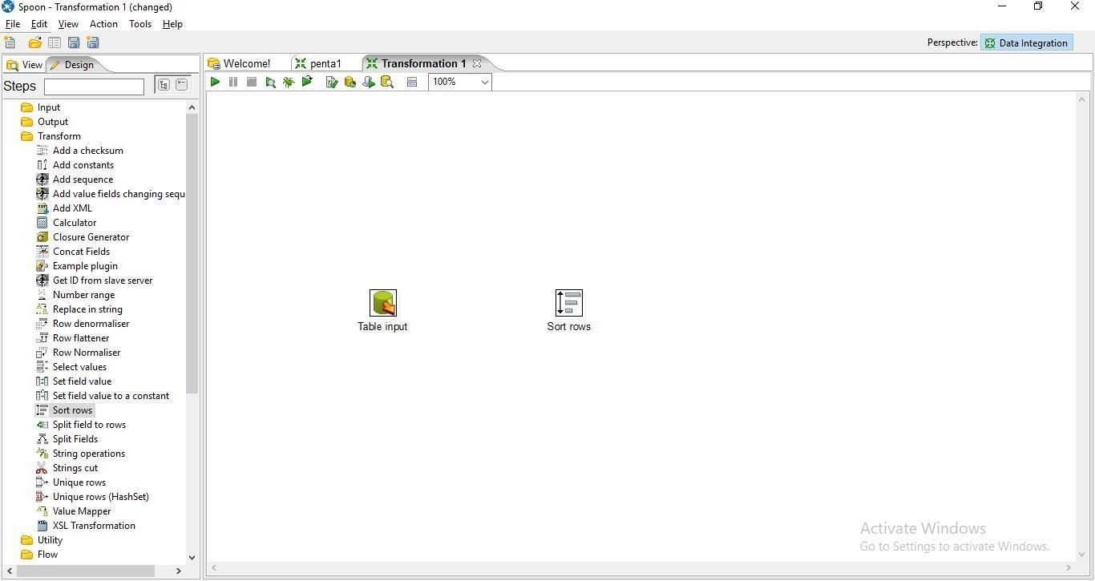

**Step 4: Hold the mouse pointer on the Table Input and then drag the output connector to the sort rows.**

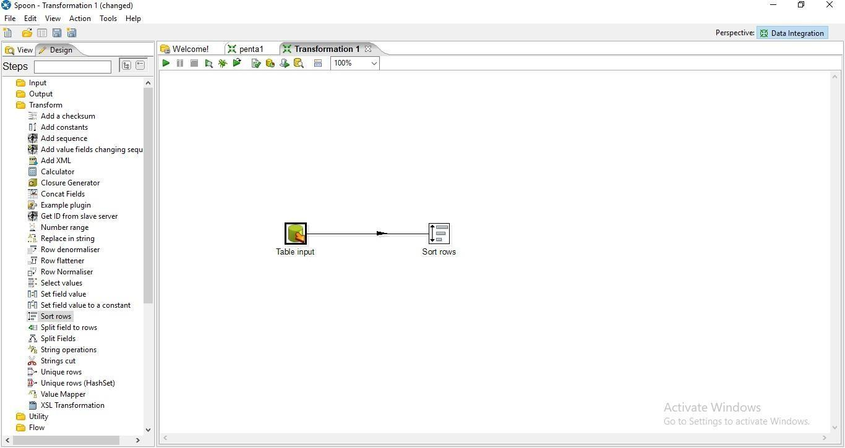

**Step 5: Double click on the sort rows**

1. **click on get fields**

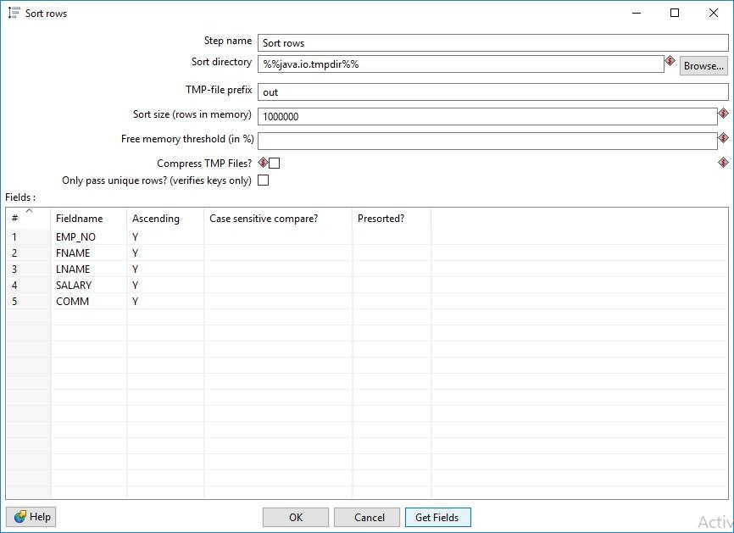

1. **Edit the fields and press ok**

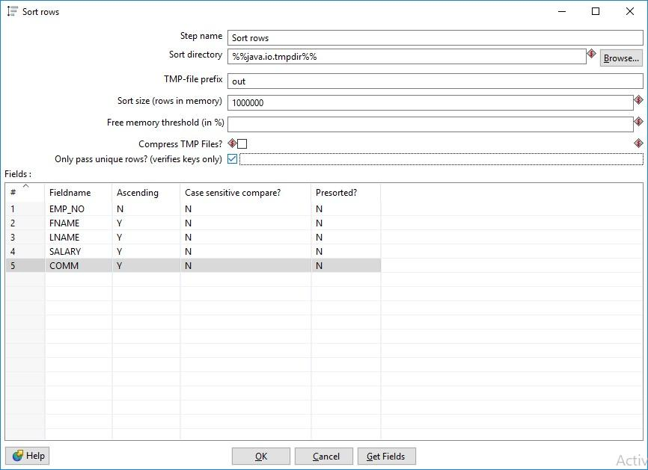

**Step 6: Click on Debug the Transformation and Click on Quick Launch.**

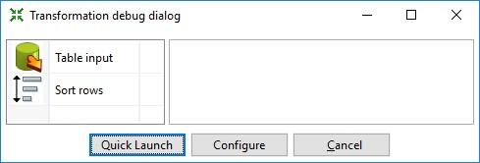

**Successful connections(Green Ticks)** 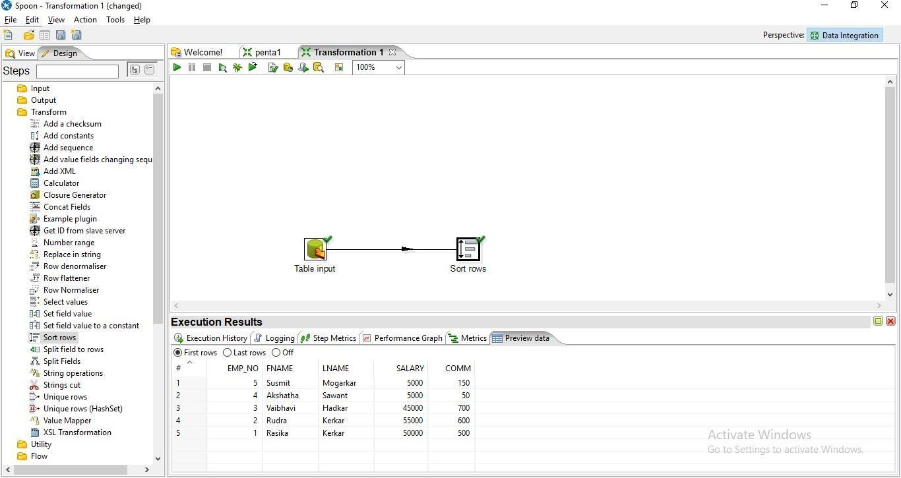

**Sorted Data**

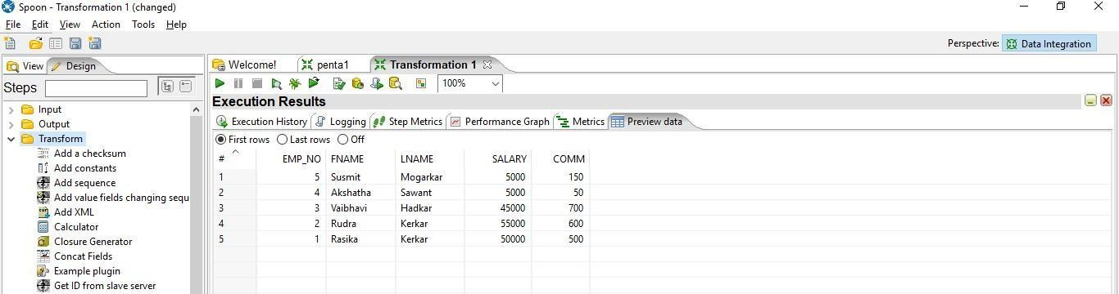

**Step 7: hold the cursor on the sort row and then drag the output connector to the table output.**

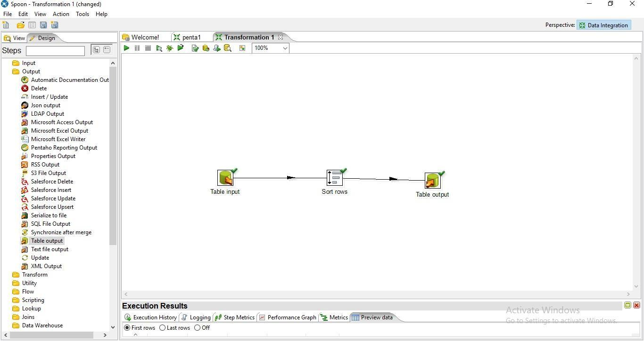

**Step 8:now perform step no 8 to steo 10 from practical 1.**

**Final Output:**

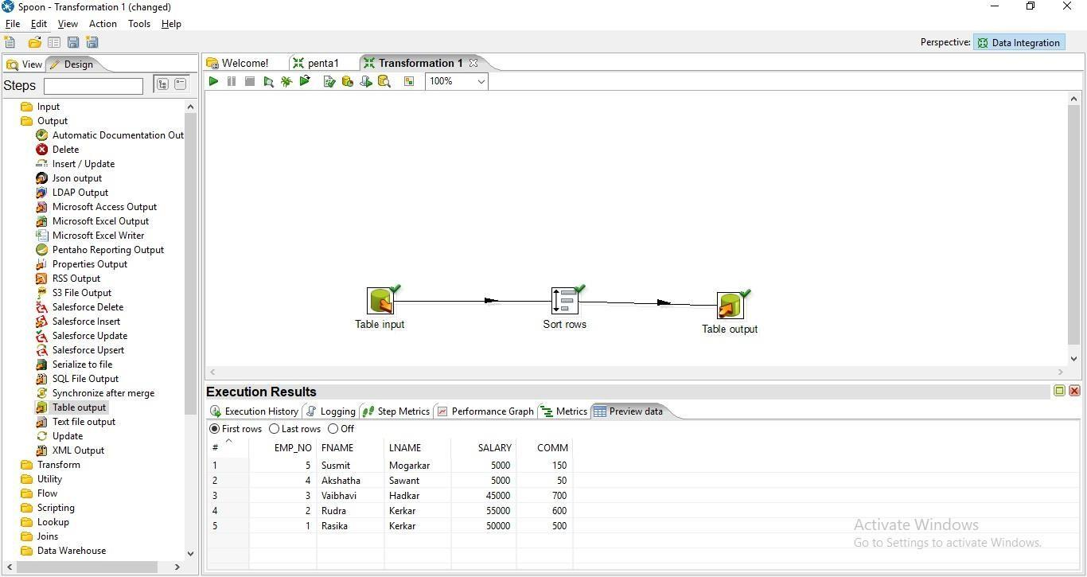

**SQL> select * from SortedTable;**

|  |  |
| --- | --- |
| **EMP_NO FNAME LNAME SALARY**  **---------- ---------- ---------- ---------- ----------** | **COMM** |
| **5 Susmit Mogarkar 5000** | **150** |
| **4 Akshatha Sawant 5000** | **50** |
| **3 Vaibhavi Hadkar 45000** | **700** |
| **2 Rudra Kerkar 55000** | **600** |
| **1 Rasika Kerkar 50000** | **500** |

**Step 9: Drag and drop Add sequence on the panel**

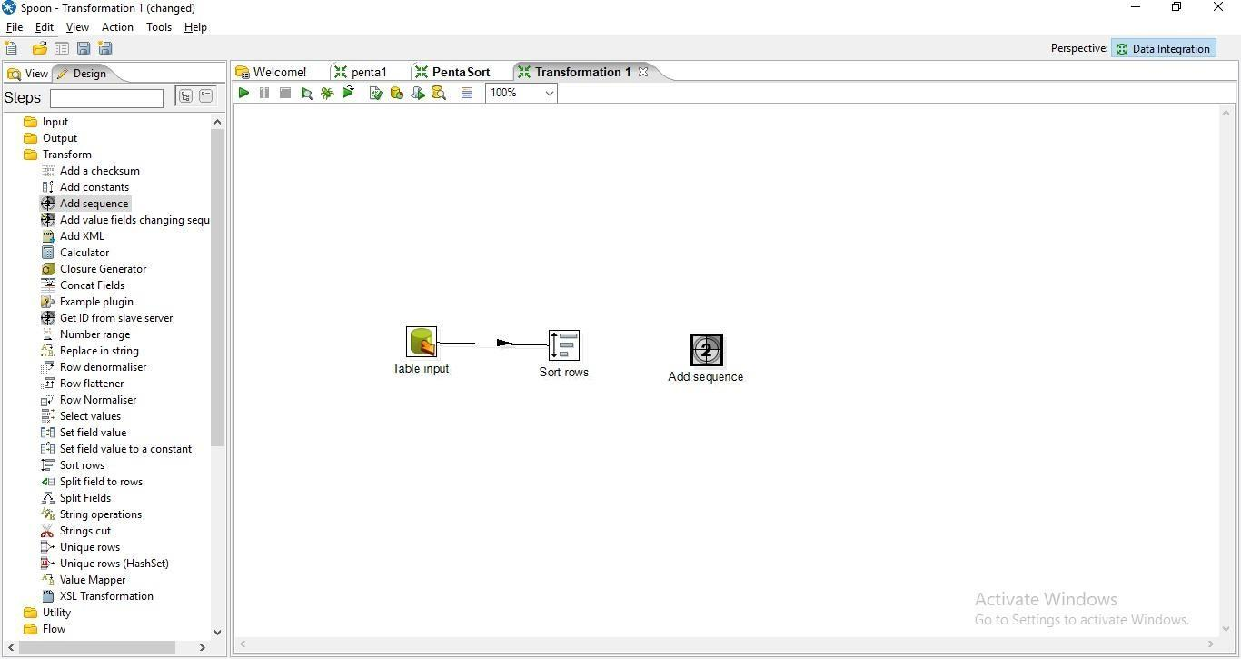

**Step 10: Hold the mous pointer on the sort rows and drag the output connector to the Add sequence control.**

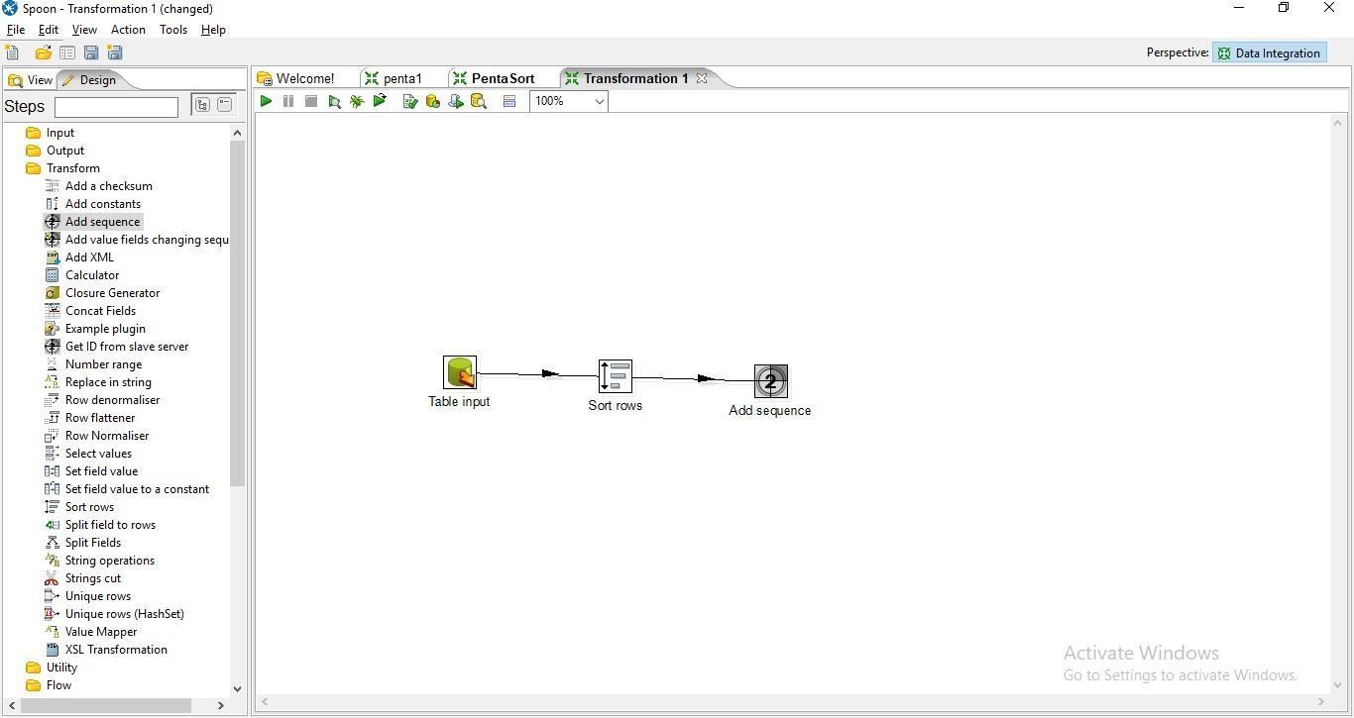

**Step 11: Double Click on Add Sequence Control**

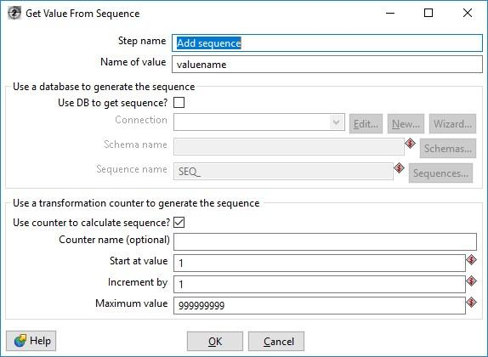

**a. Enter the values for Start at Values,Increment by and Maximum Values and press ok.**

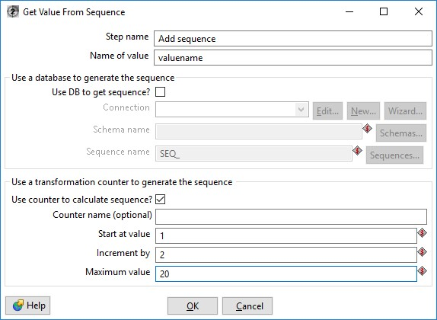

**Step 12: Click on Debug the Transformation and click on Quick Launch**

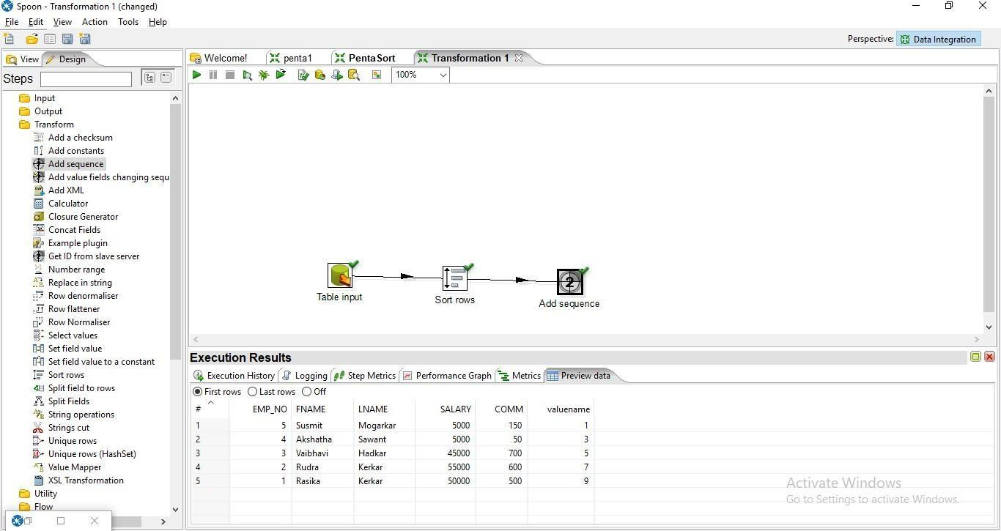

**Step 13: Drag and drop the table output on the panel**

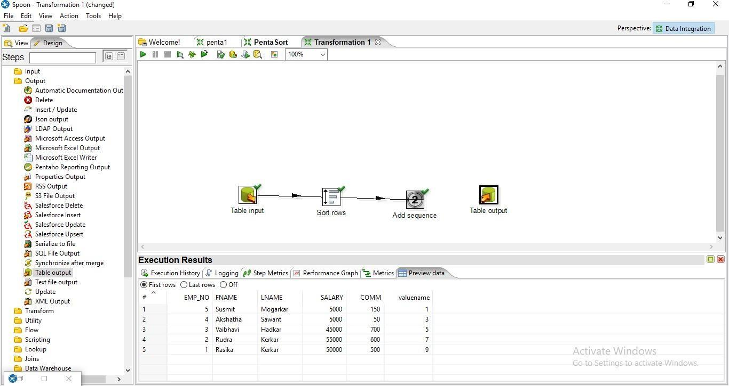

**Step 14: Hold the mouse pointer on the add sequence control and drag the output connector to the table output.**

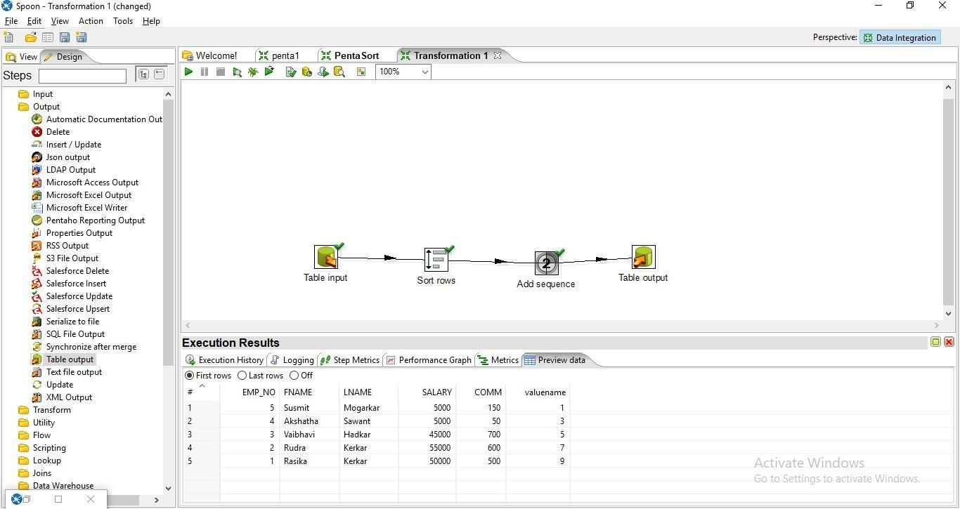**Step 15: Double Click on the table output.**

1. **Click on Database Fields**

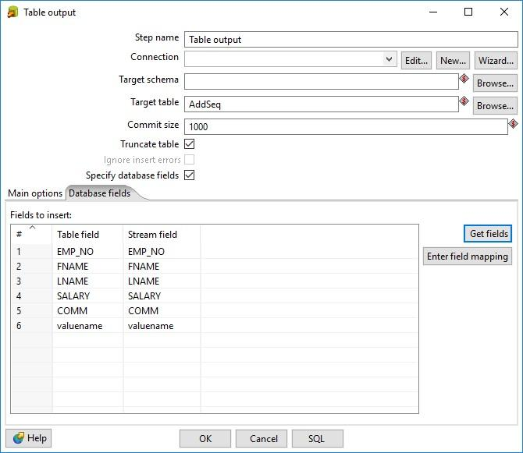

1. **Click on SQL**

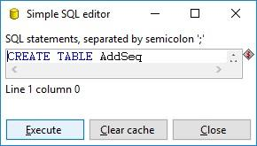

1. **Click on Execute an then press ok**

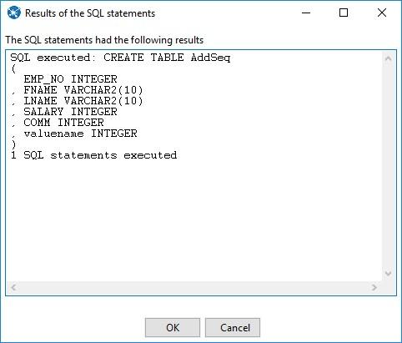

**Step 16: Click on debug Transformation and then quick Launch**

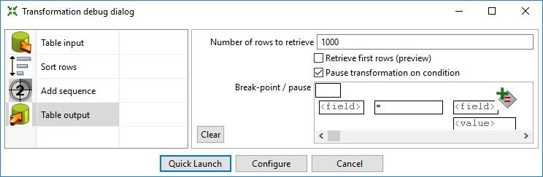

**Output**

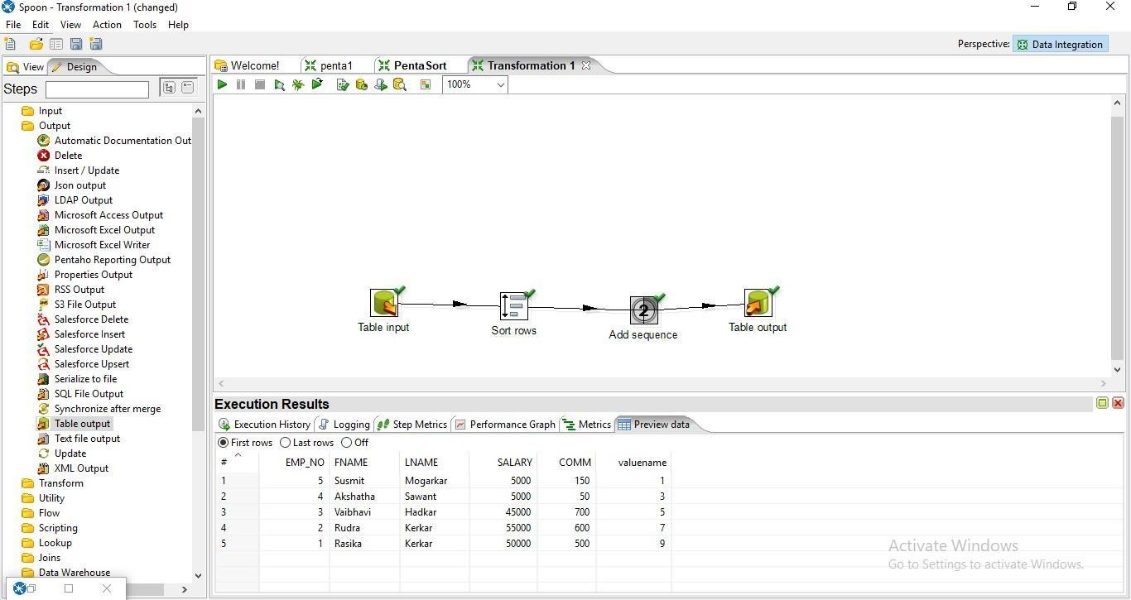

**SQL> select * from AddSeq;**

**EMP_NO FNAME LNAME SALARY COMM VALUENAME**

**---------- ---------- ---------- ---------- ---------- ----------**

**5 Susmit Mogarkar 5000 150 1**

**4 Akshatha Sawant 5000 50 3 3 Vaibhavi Hadkar 45000 700 5 2 Rudra Kerkar 55000 600 7**

**1 Rasika Kerkar 50000 500 9**

**3. Calculator Operation**

**Step 1: Perform first 5 steps same as practical 1.**

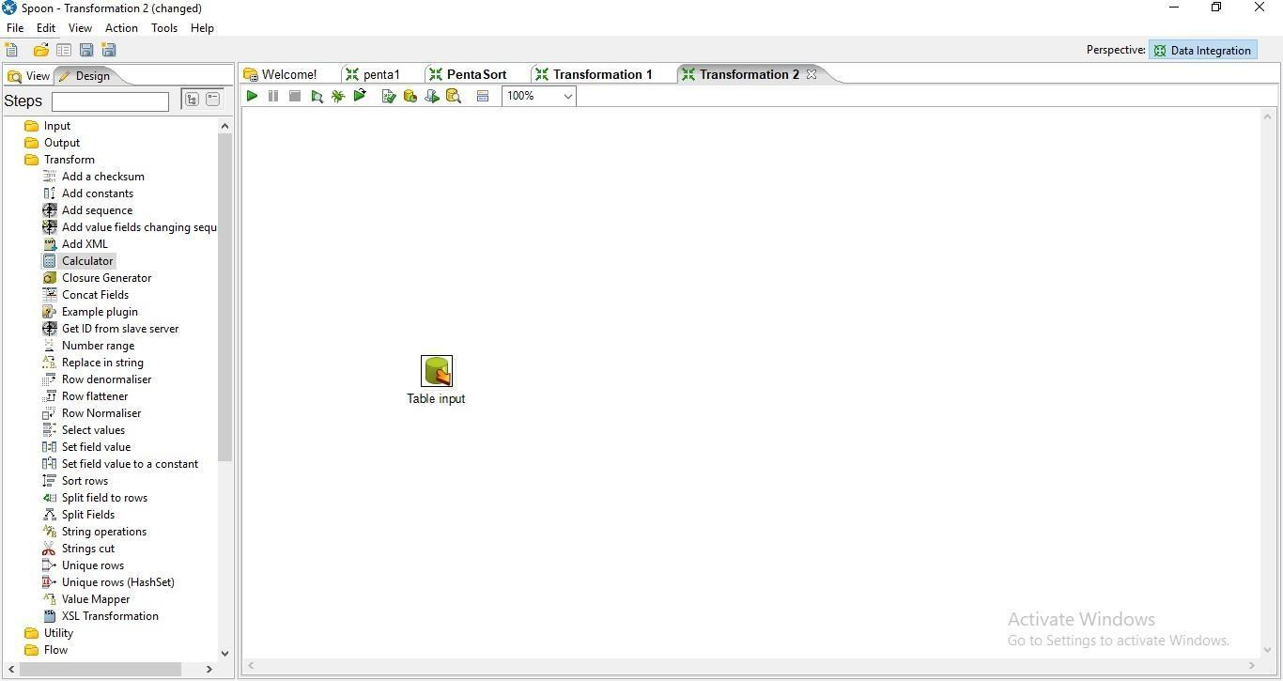

**Step 2: Drag and Drop Calculator from transformation on the panel.**

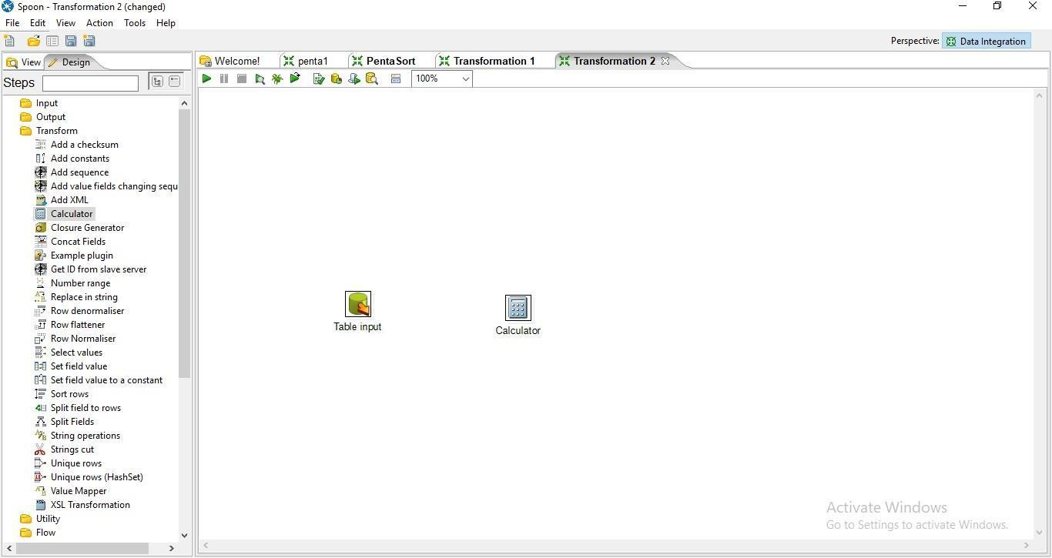

**Step 3: Hold the mouse pointer on the Table input and drag the output connector to the calculator control.**

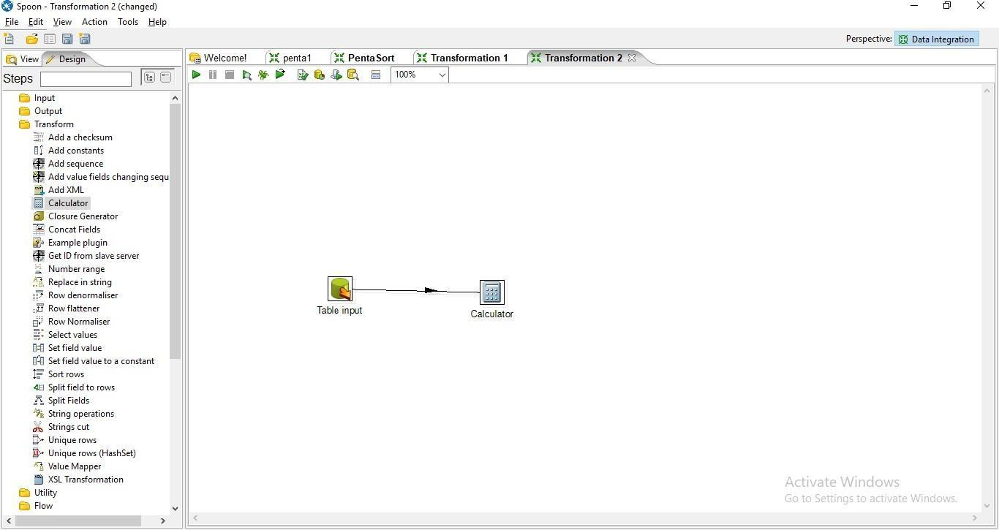

**Step 4: Double Click on the Calculator**

1. **specify the new field name**
2. **select the calculation function.**

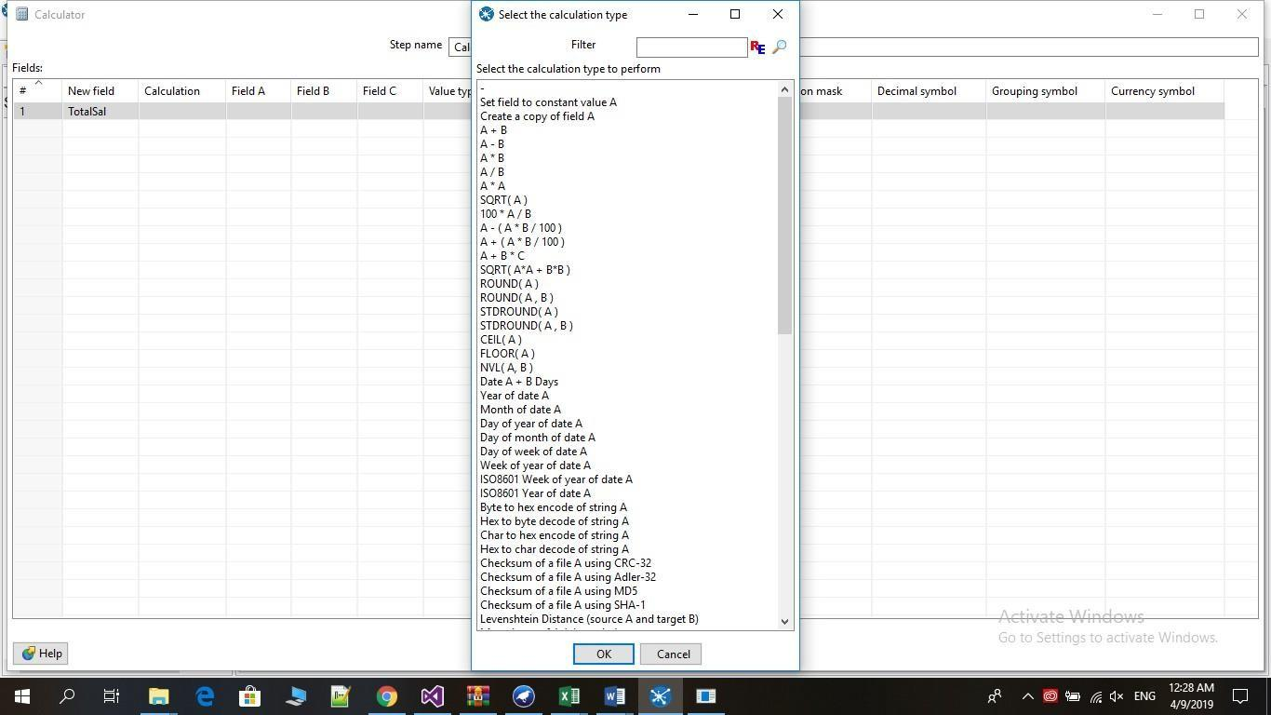

1. **Enter Field A, Field B, Value type and Length and press ok.**

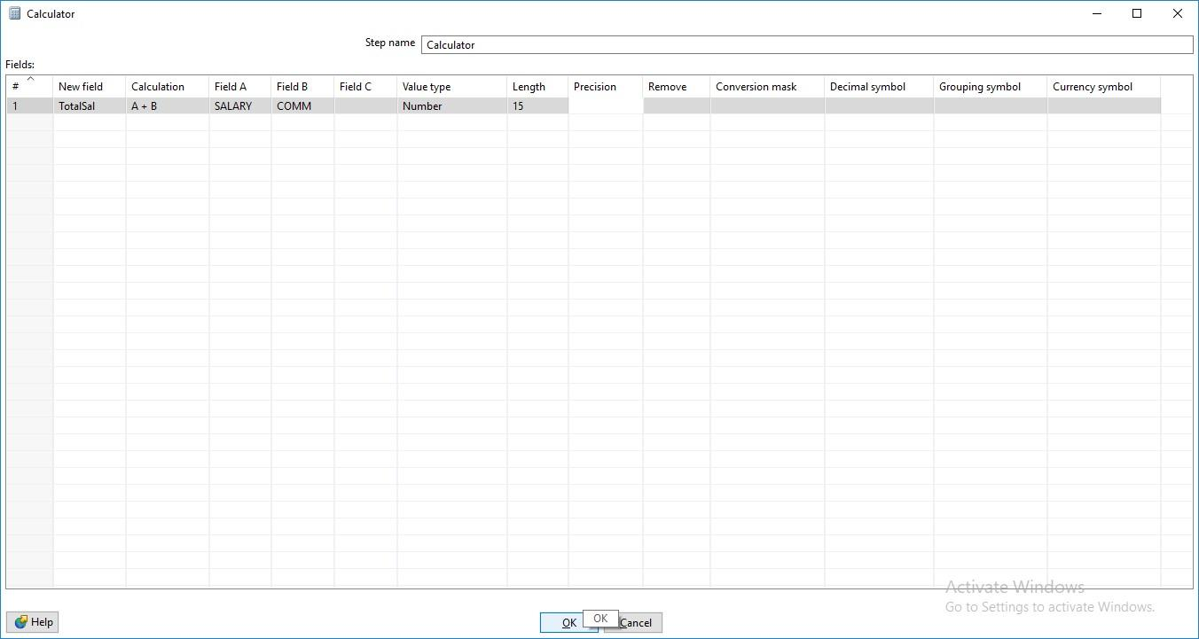

**Step 5: Click on Debug transformation and click on Quick Launch.**

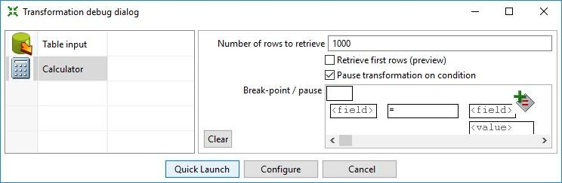

**Preview**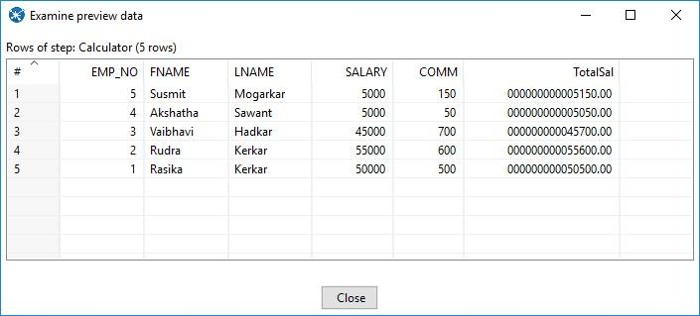

**Step 6: Now Perform the steps 6-10 same as practical 1.**

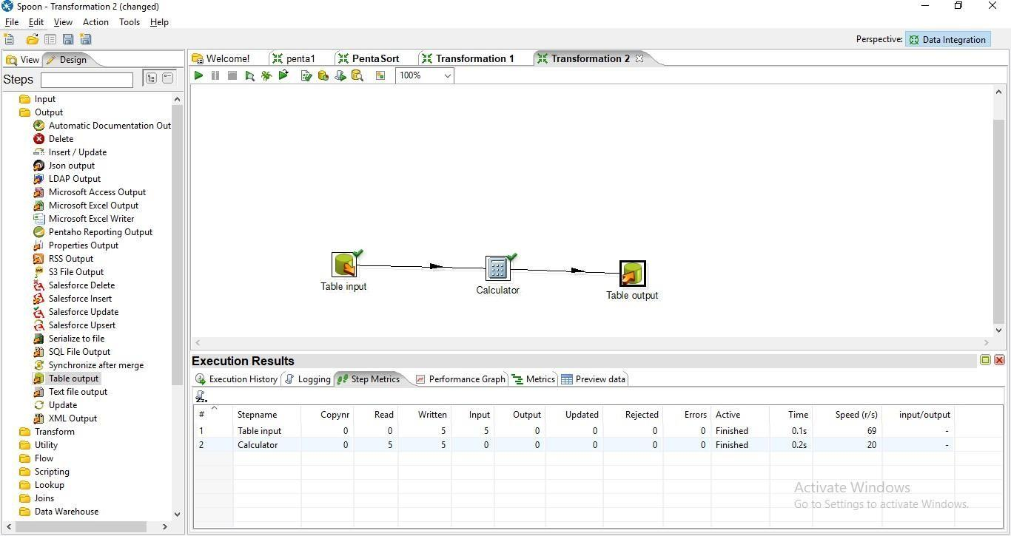

**Step 7: Click on Debug Transformation and then click on Quick Launch**

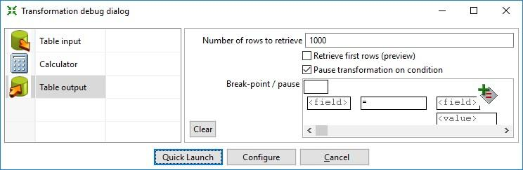

**Output:** 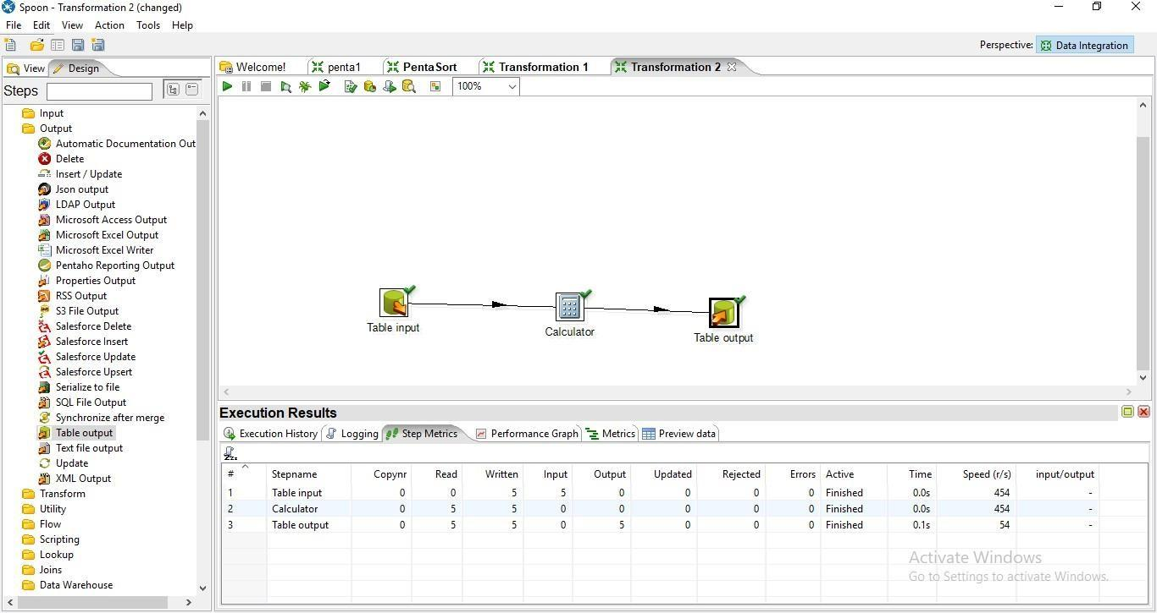

**SQL> select * from calcTable;**

**EMP_NO FNAME LNAME SALARY COMM TOTALSAL**

**---------- ---------- ---------- ---------- ---------- ----------**

|  |  |  |  |
| --- | --- | --- | --- |
| **1 Rasika Kerkar** | **50000** | **500** | **50500** |
| **2 Rudra Kerkar** | **55000** | **600** | **55600** |
| **3 Vaibhavi Hadkar** | **45000** | **700** | **45700** |
| **4 Akshatha Sawant** | **5000** | **50** | **5050** |
| **5 Susmit Mogarkar** | **5000** | **150** | **5150** |

**Concatenation Operation**

**Step 1: Perform first 6 steps same as practical 1.**

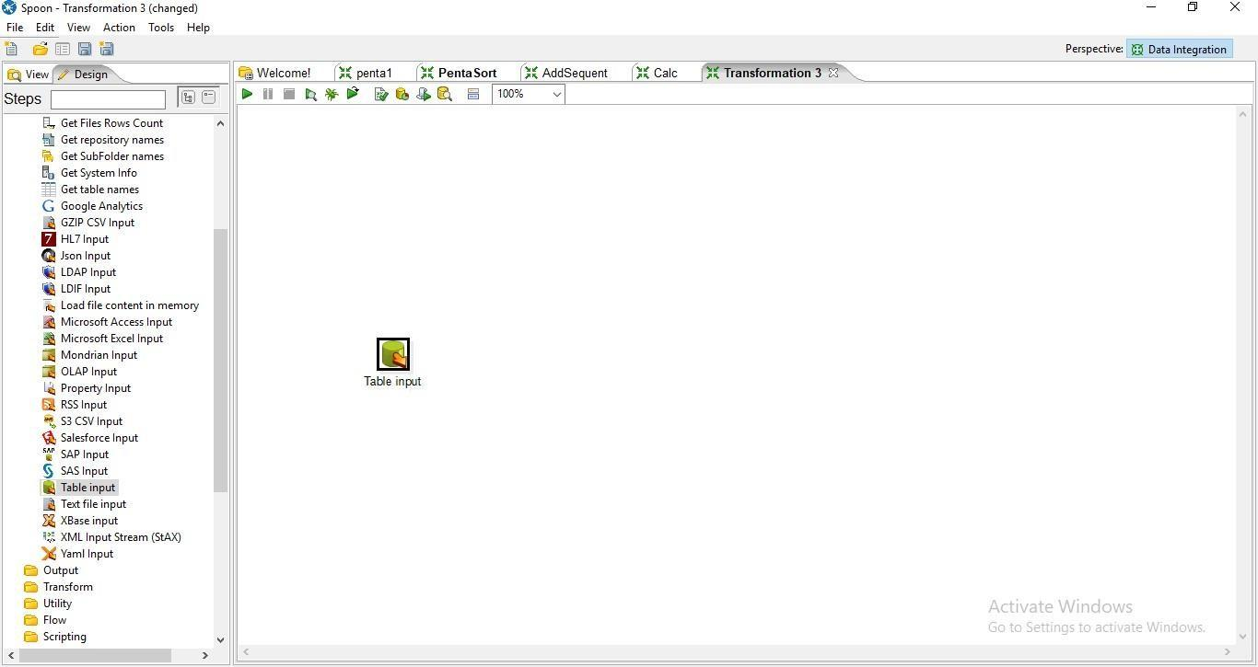

**Step 2: Drag and drop Concat Field**

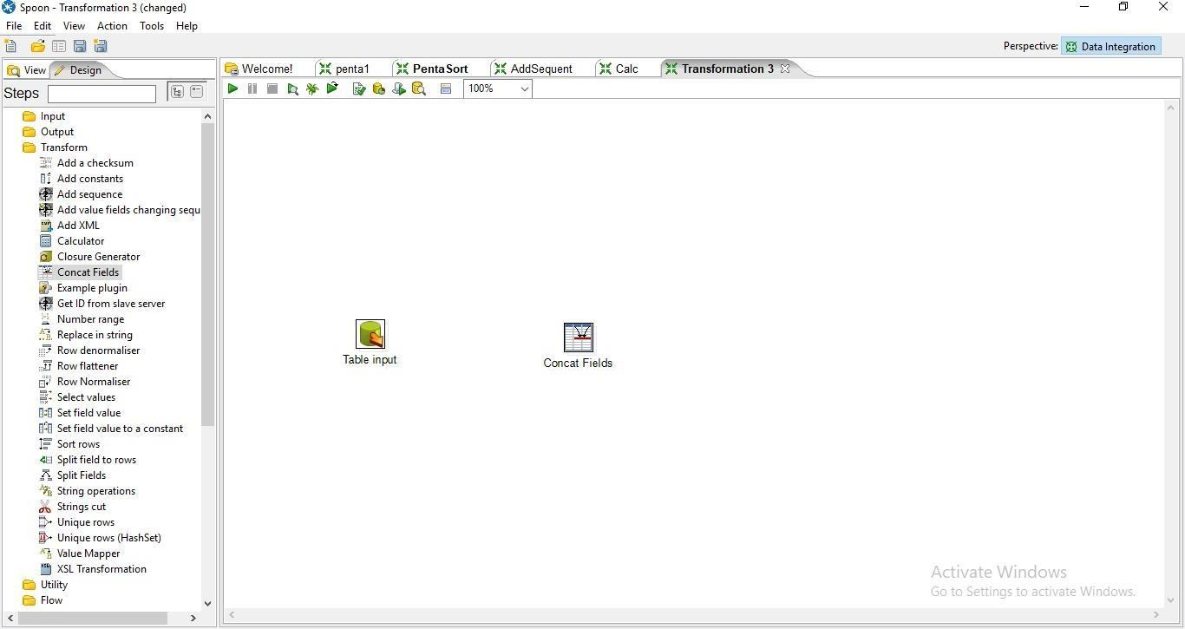

**Step 4: Hold mouse pointer on input table and drag the output connector to the Concat field.**

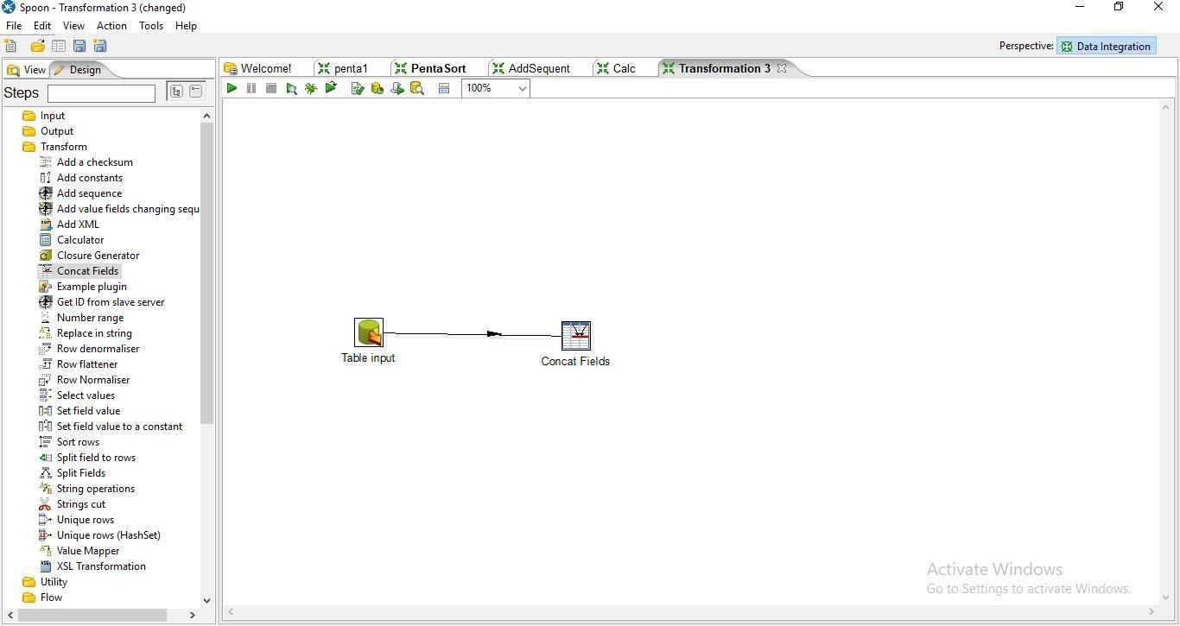

**Step 5: Double Click on Cncat Field**

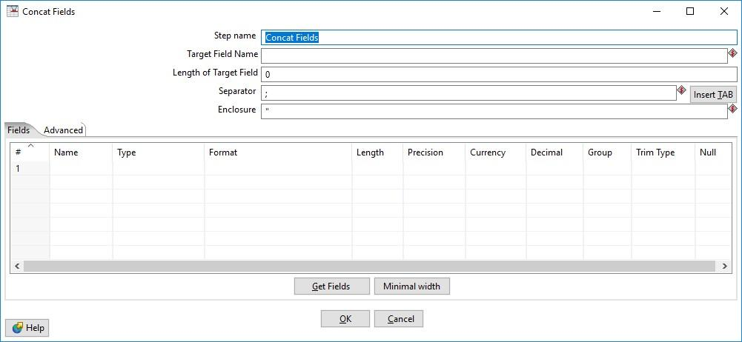

1. **Enter the values for Target Field Name, Length of the Target Field and the Seperator and press on Get Fields**

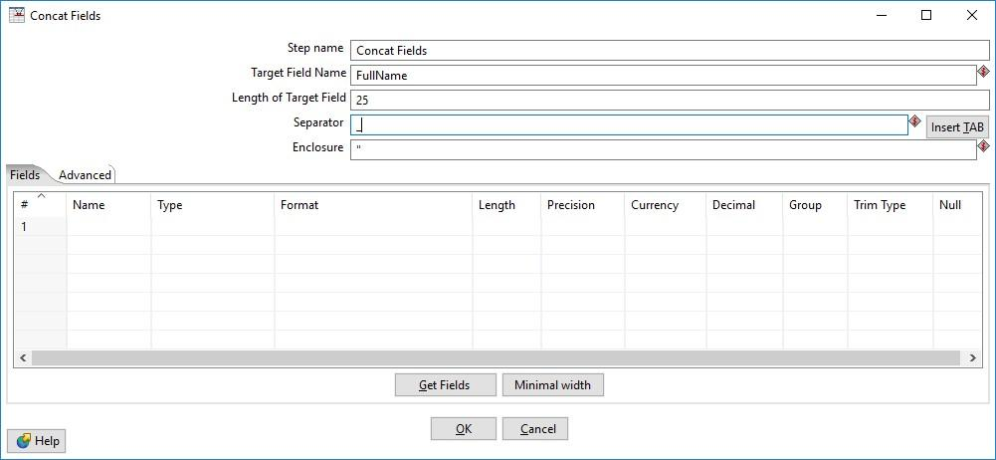

1. **Select the columns that you want to concat**

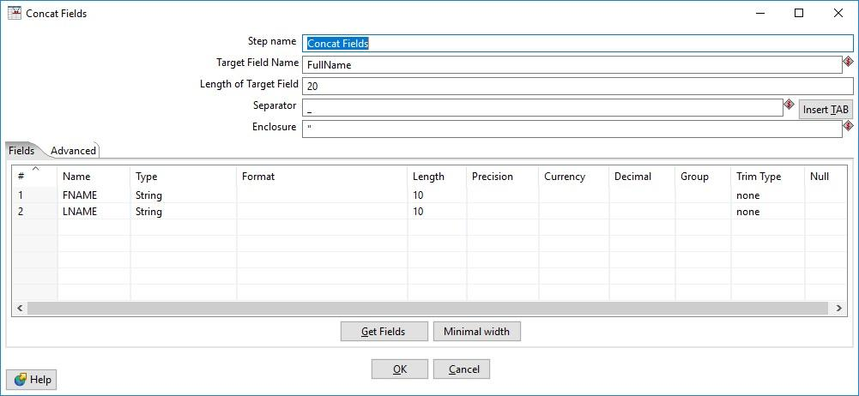

**Step 6: Click on Debug transformation and click on Quick Launch.**

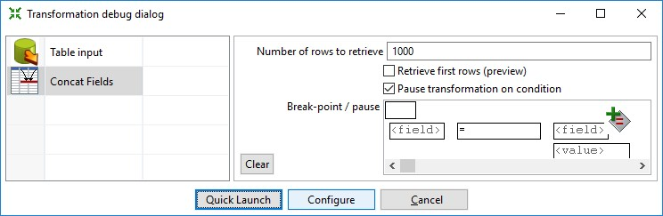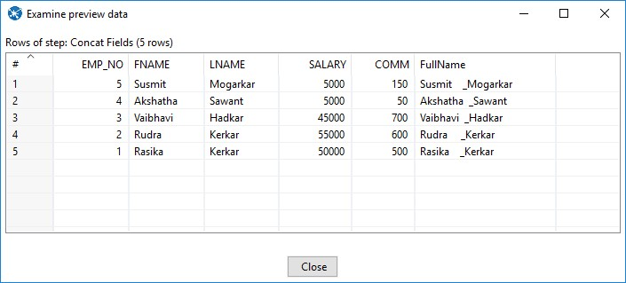

**Step 7:Now Perform the steps 6-10 same as practical 1.**

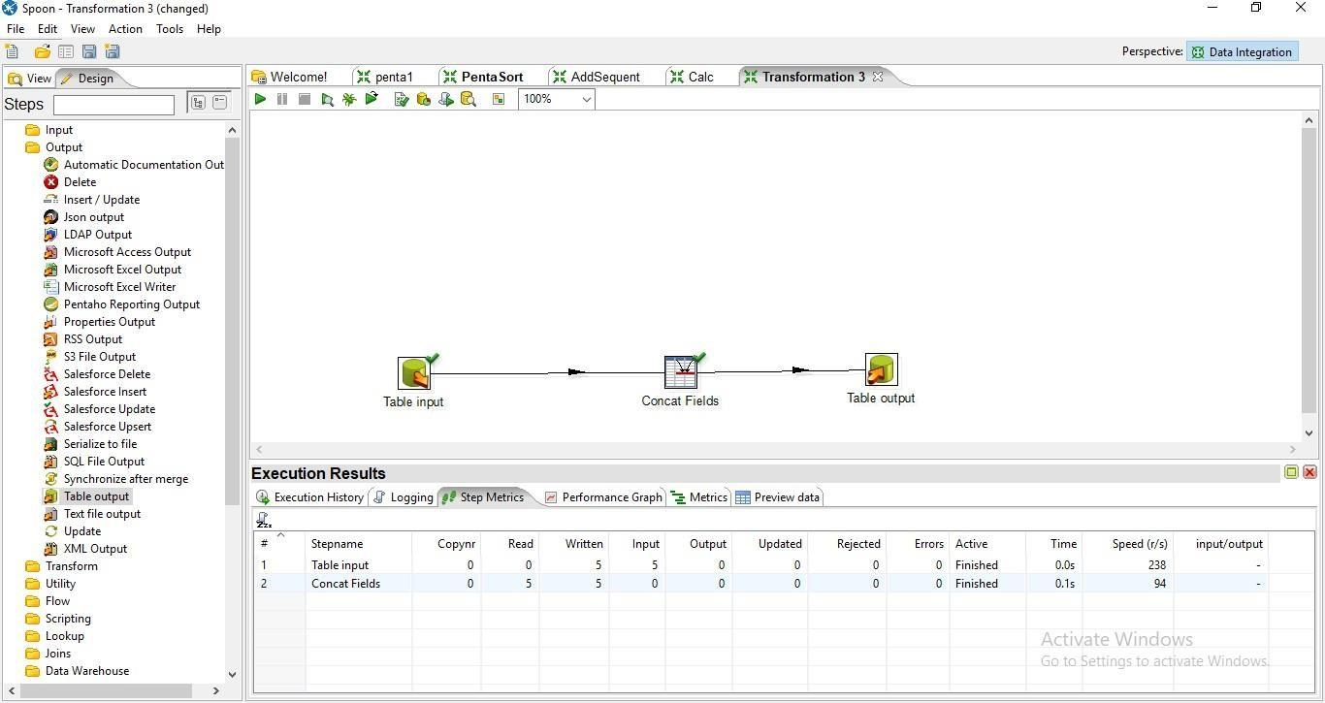

**Step 8: Click on debug Transformation and click on Quick Launch**

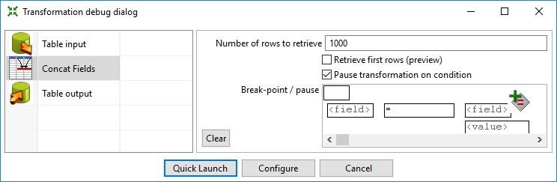

**Output:**

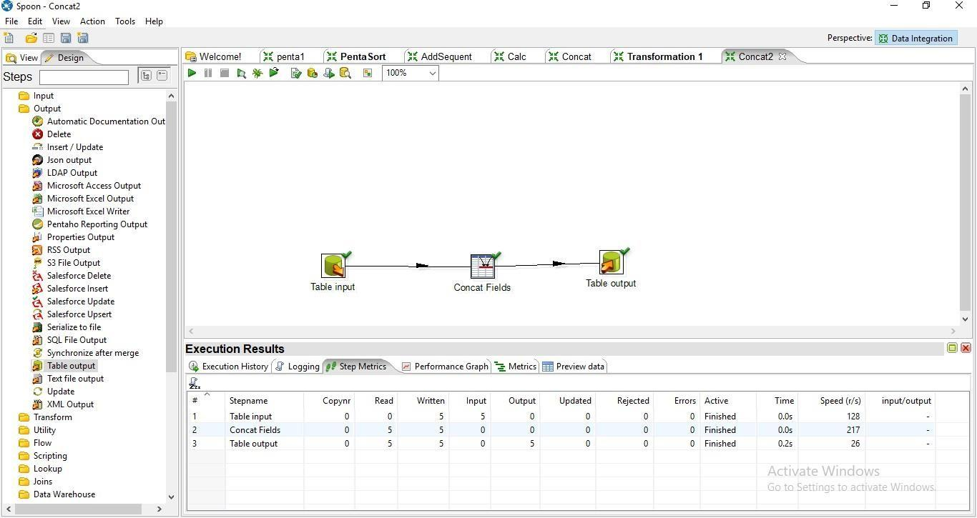

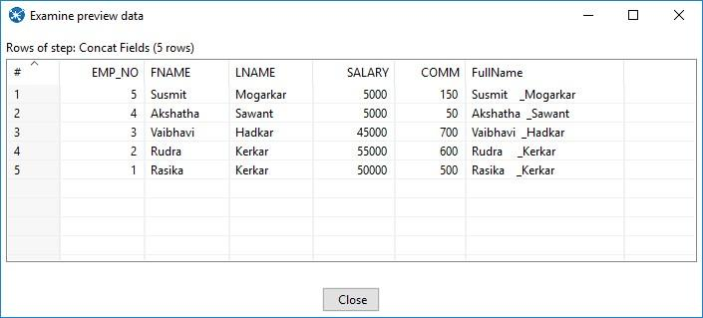

**SQL> select * from Concat;**

**EMP_NO FNAME LNAME SALARY COMM FULLNAME**

**---------- ---------- ---------- ---------- ---------- -------------------------**

|  |  |  |  |
| --- | --- | --- | --- |
| **1 Rasika Kerkar** | **50000** | **500** | **Rasika _Kerkar** |
| **2 Rudra Kerkar** | **55000** | **600** | **Rudra _Kerkar** |
| **3 Vaibhavi Hadkar** | **45000** | **700** | **Vaibhavi _Hadkar** |
| **4 Akshatha Sawant** | **5000** | **50** | **Akshatha _Sawant** |
| **5 Susmit Mogarkar** | **5000** | **150** | **Susmit _Mogarkar** |

1. **Splitting Operation**

**Step 1: Perform first 6 steps same as practical 1.**

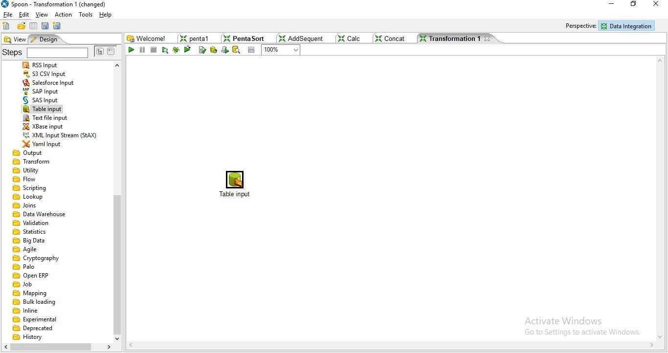

**Step 2: Drag and drop Split Field on the Panel**

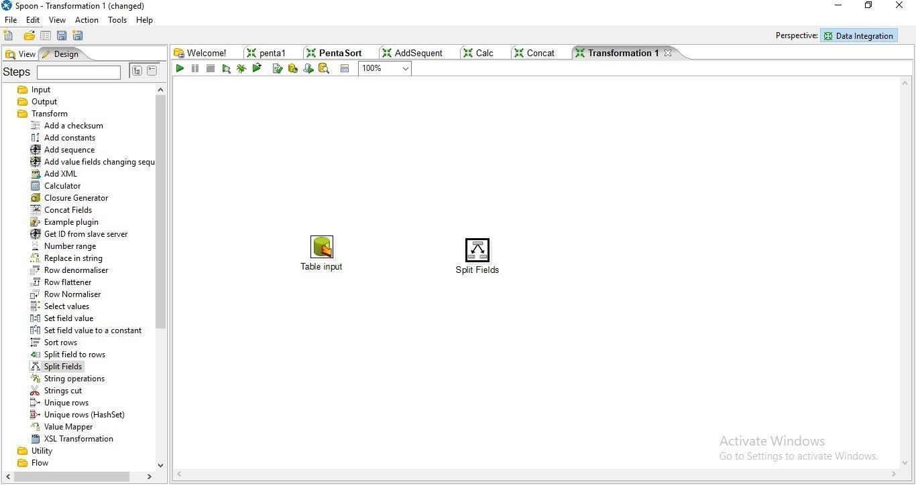

**Step 3: Hold the mouse pointer og table input and drag it to the Split Field.**

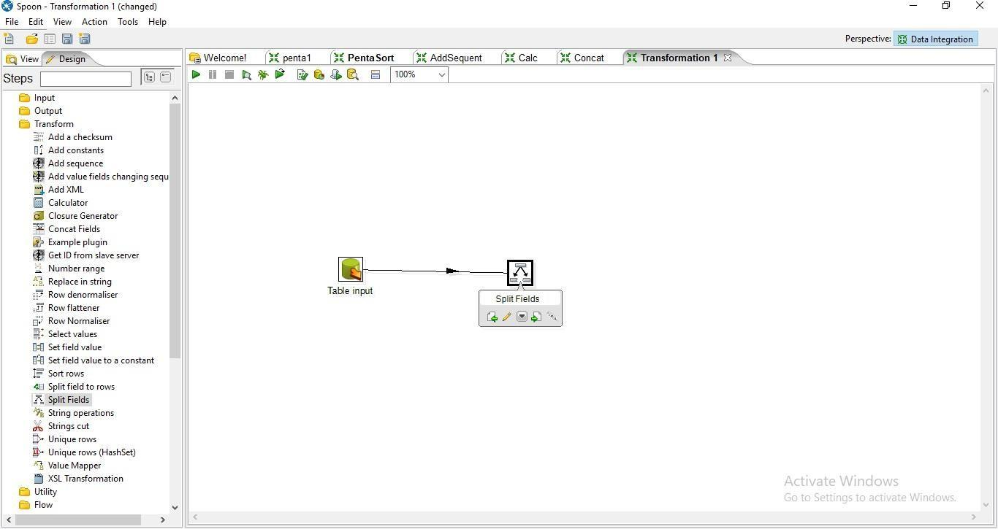

**Step 4: Double Click On Split Field.**

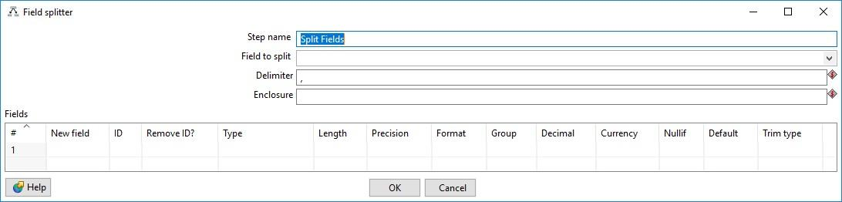

**a. Enter the values For Field to Split, Delimiter and the field names and press ok**

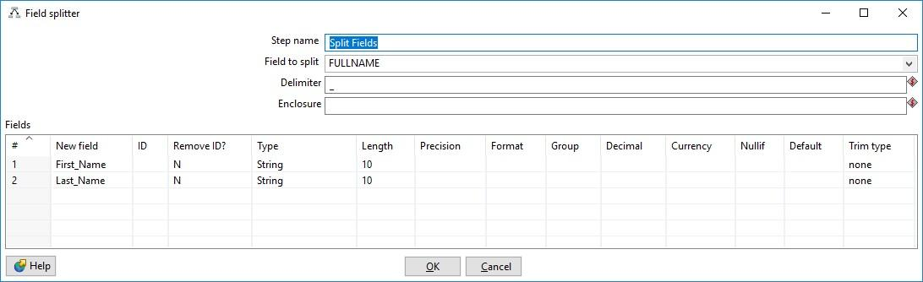

**Step 6: Click on Debug transformation and Click on Quick Launch.**

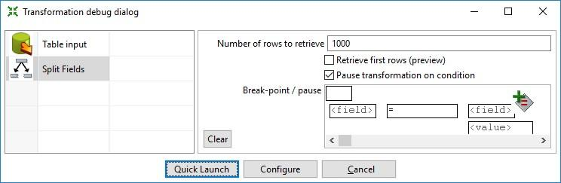

**Step 7: Perform steps 6-10 same as practical 1.**

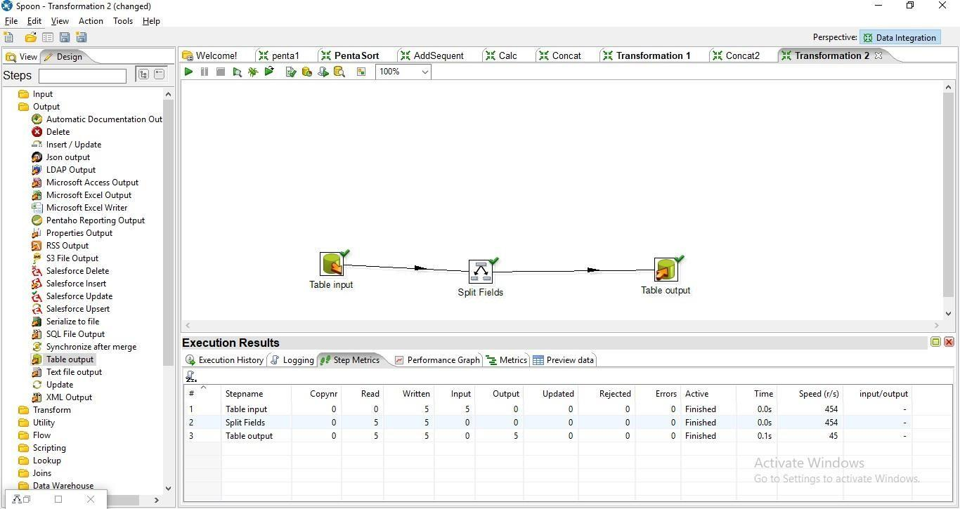  **Step 8: Click on Debug transformation and Click on Quick Launch.**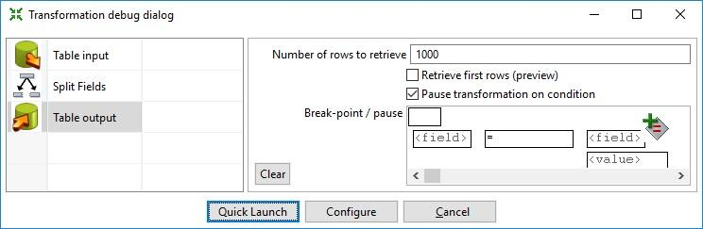

**Output:**

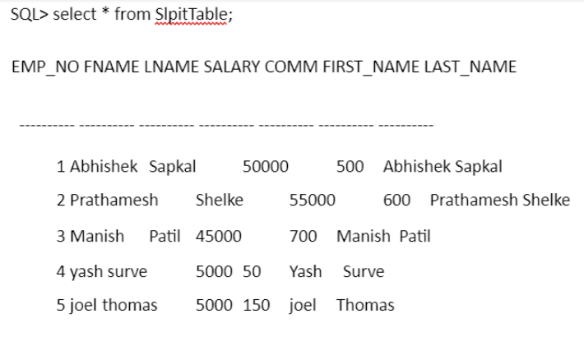

**6. Number Range:**

**Create Student table in SQL**

**SQL> select * from student ;**

**ROLL_NO PERCENTAGE**

**---------- ----------**

1. **55**
2. **59**
3. **68**
4. **75**
5. **83**
6. **35**
7. **88**

**7 rows selected. In Pentaho**

**Step 1: Perform first 6 steps same as practical 1.**



Step2: Drag and drop Number Range transformation and double click on it.

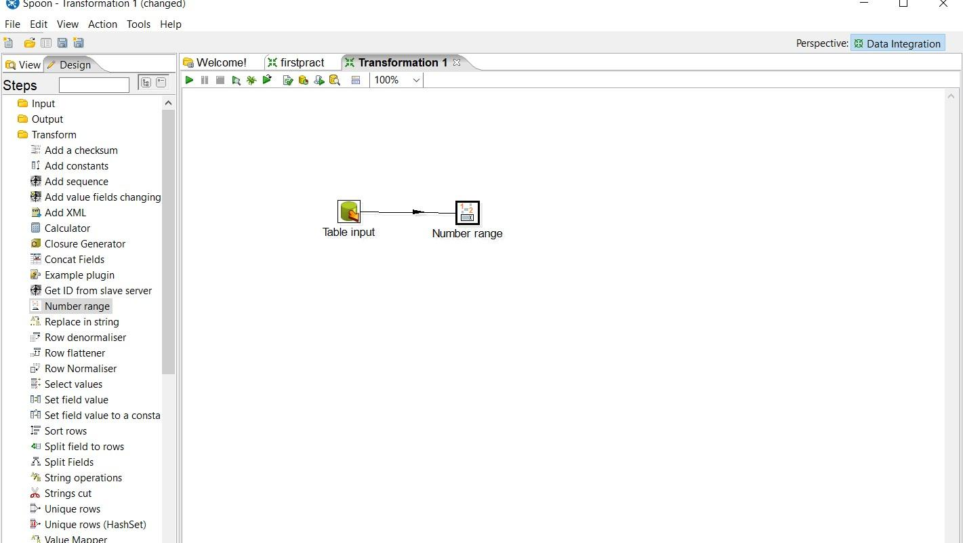

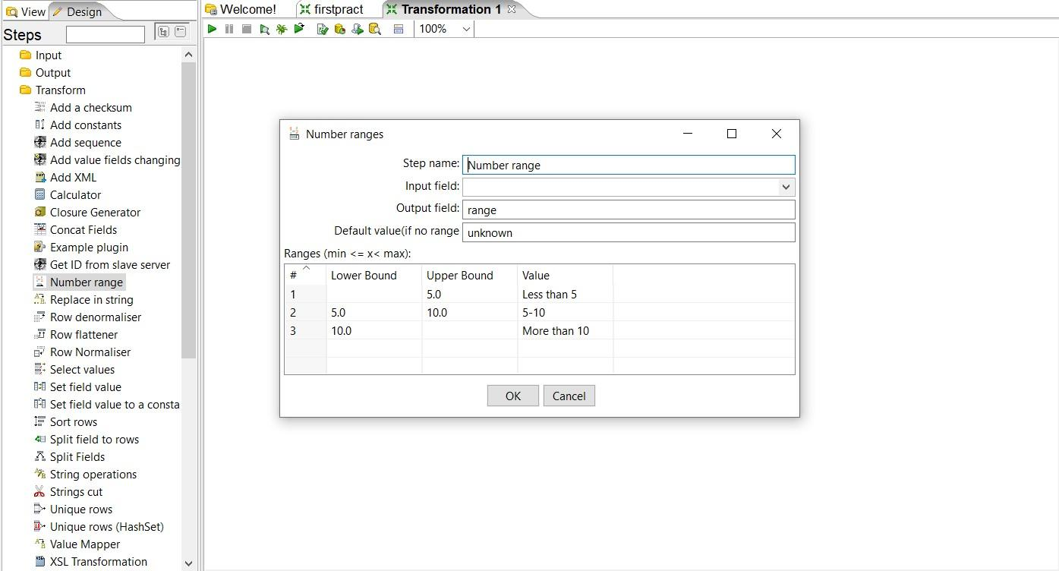

Step3: Set values for Input field, Output field, Lower bound, Upper bound and value according to the values specified in percentage column.

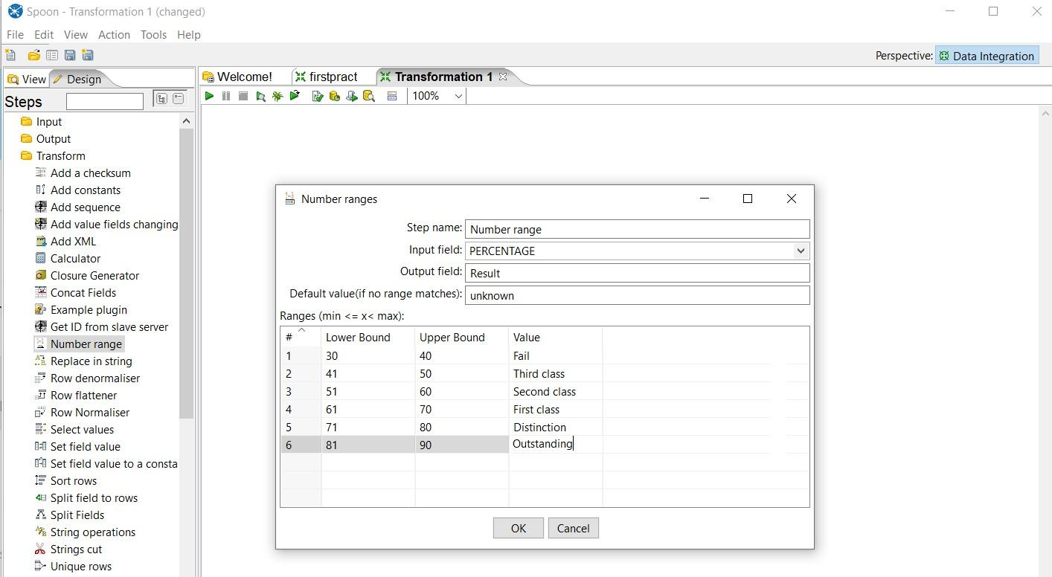

Step4: Click on Quick launch

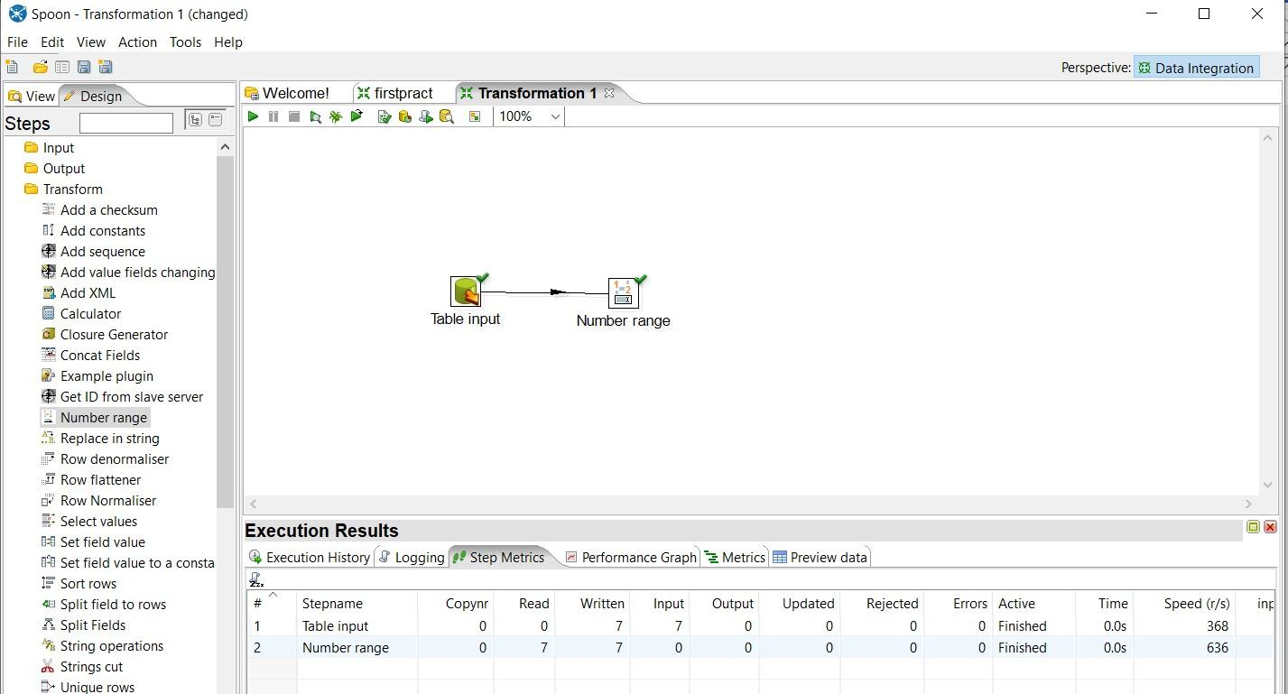

Step 5: Click on Preview data

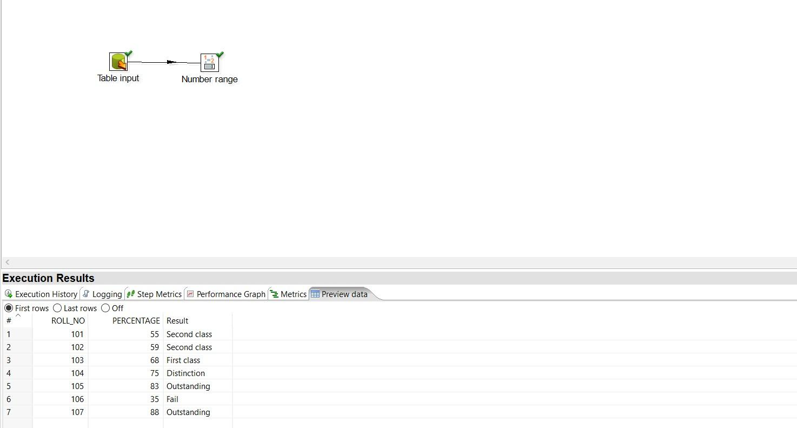

**7. String Operation:**

**Required SQL table:**

SQL> select * from newemp;

EMPN ENAME DEPT JOB SALARY

---- -------------------- ---- ---------- ----------

|  |  |
| --- | --- |
| E001 | SAPKAL D002 Manager 50000 |
| E002 | SHELKE D001 Hr 40000 |
| E003 | PATIL D002 30000 |
| E004 | TUBHE D003 Manager 14000 |
| E005 | GHADGE D003 Manager 17000 |

E006 THONGE D002 Sales 18000

6 rows selected.

**Step 1: Perform first 6 steps same as practical 1.**

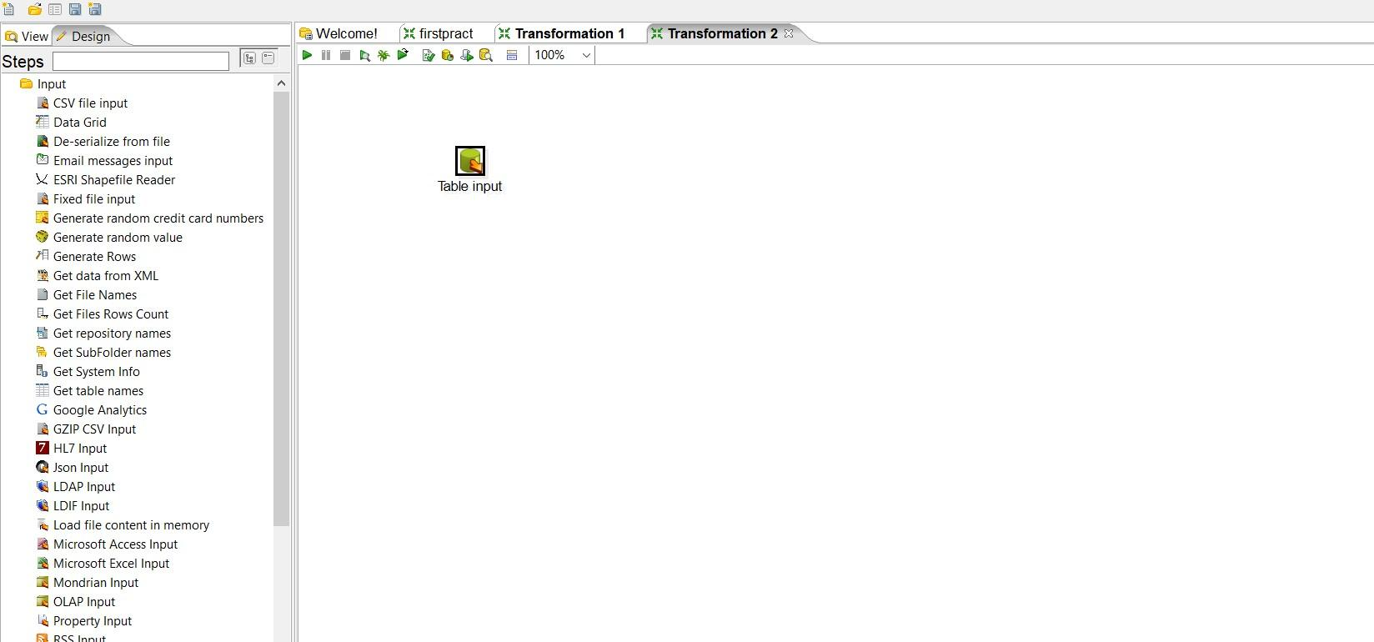

Step 2: Drag and drop String operation transformation, make connection between table input and string operation and double click on it.

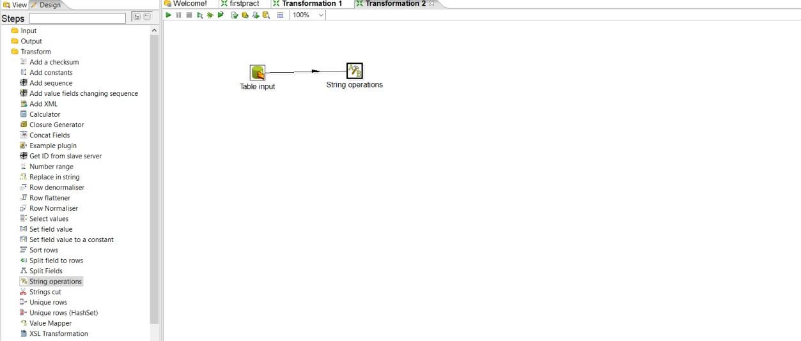

Step3: Set values for the parameters

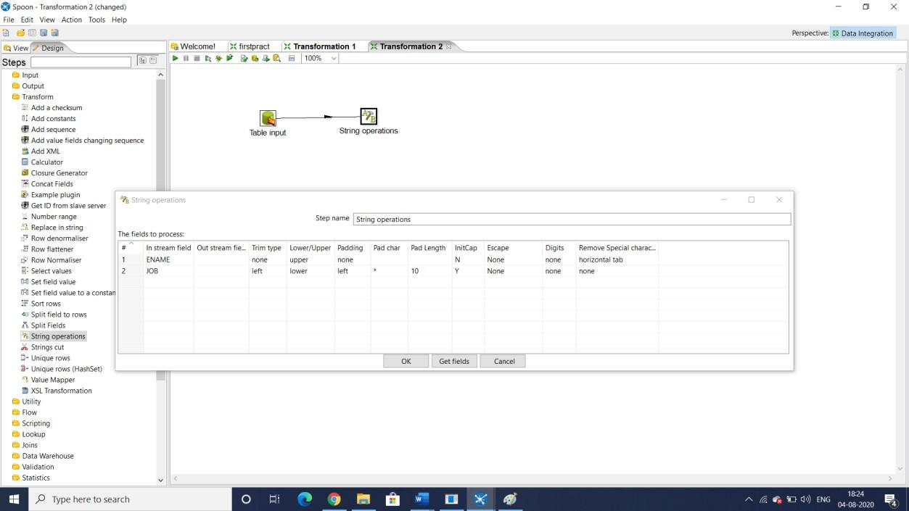

Step 4: Launch the transformation

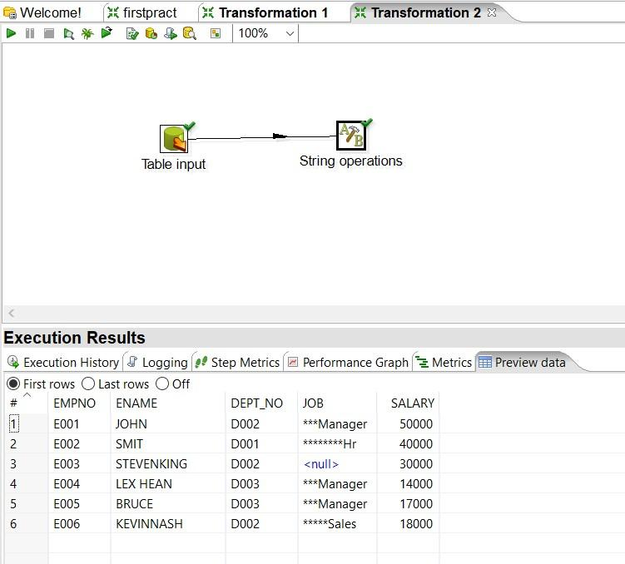

Step 5: Drag and drop output table

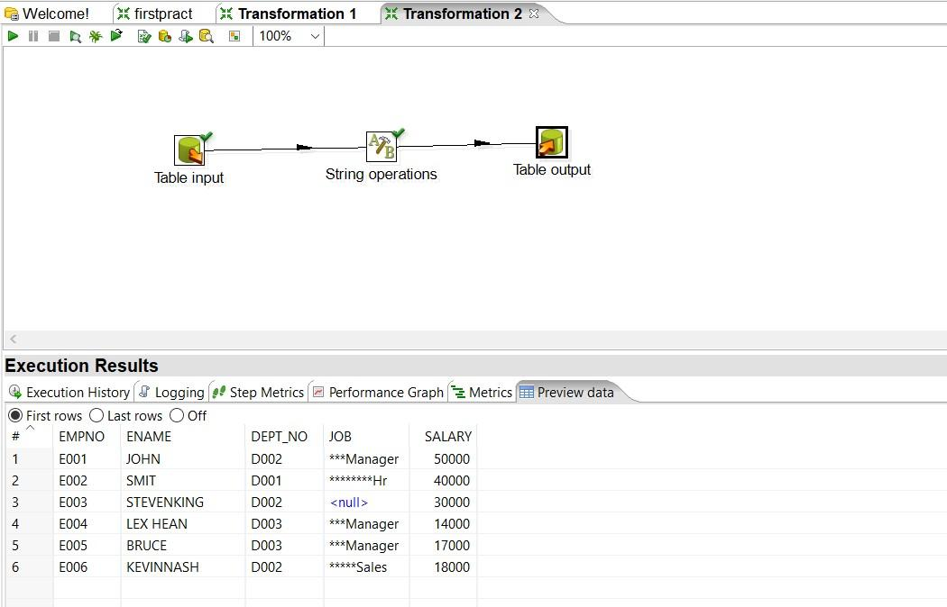

Step 6: Launch the transformation

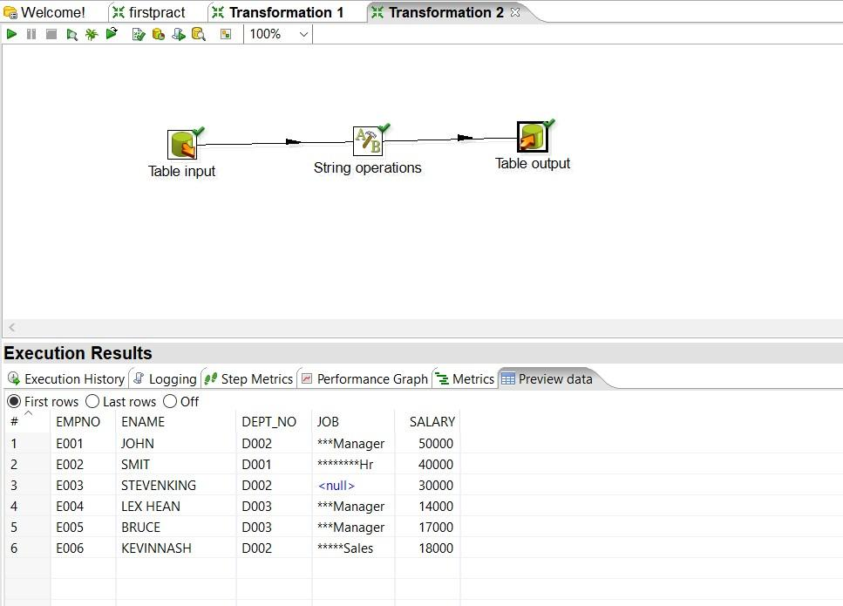

Step 7: In SQL output table

SQL> select * from stringtable;

EMPN ENAME DEPT JOB SALARY

---- -------------------- ---- ---------- ----------

E001 SAPKAL D002 ***Manager 50000

E002 SHELKE D001 ********Hr 40000

E003 PATIL D002 30000

E004 GHADGE D003 ***Manager 14000

E005 TUBHE D003 ***Manager 17000

E006 THONGE D002 *****Sales 18000

6 rows selected.

8. Copy contents of.CSV file to the target table

Step1:Drag and drop CSV file input on a panel

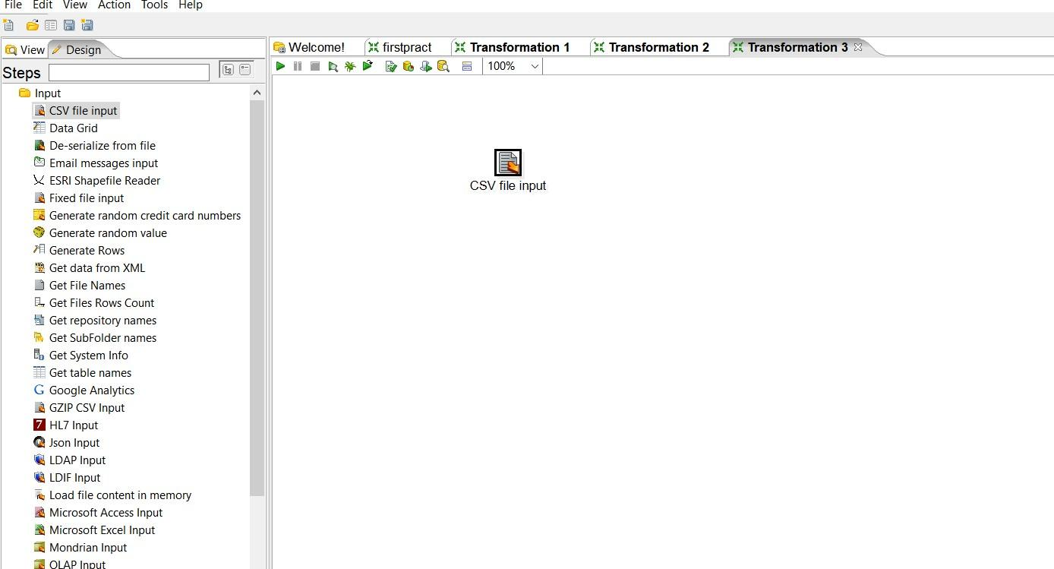

Step2: Double click on it and open respective CSV file, Lazy conversation and

Header row present? Options should be checked, click on Getfield and then ok.

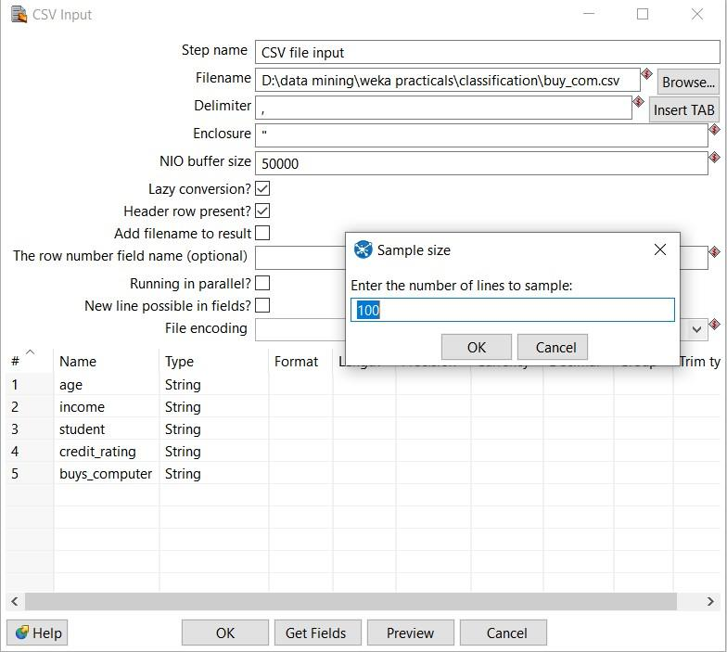

In this step we can change data type and format of CSV files after doing setting click on ok

Step3: Drag and drop Table output and connect it with CSV file.

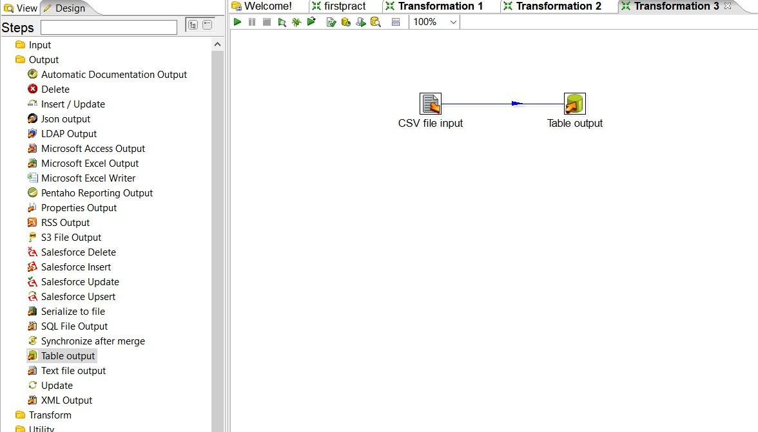

Step4: Double click on Table output and create new connection and follow same stapes like before and launch the transformation.

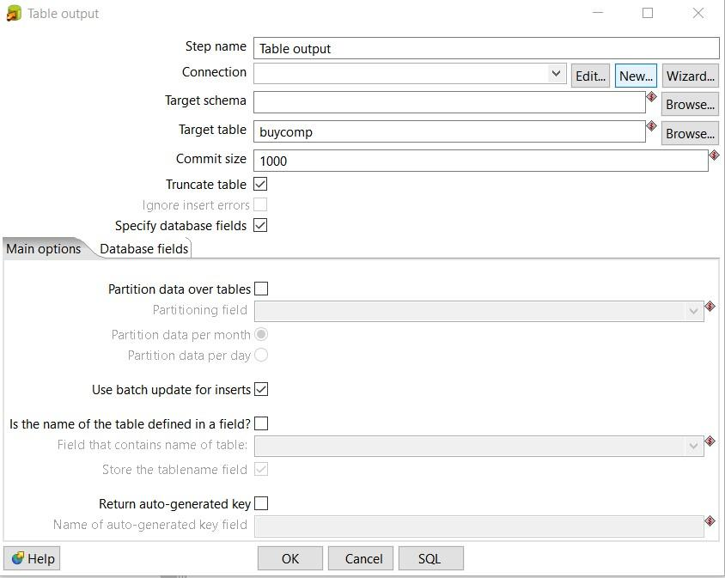

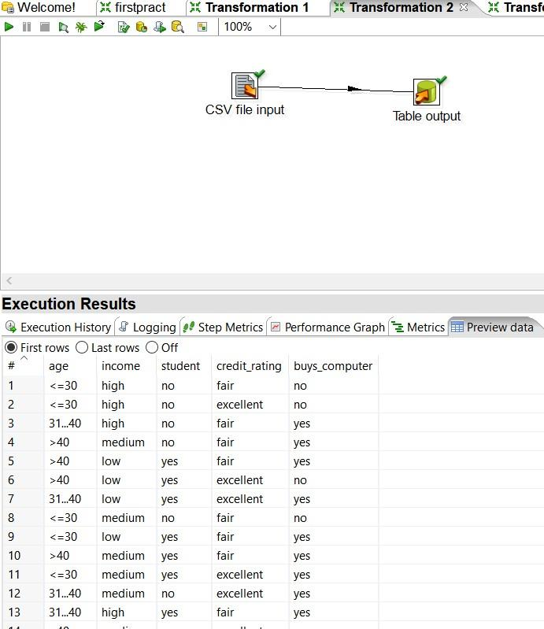

Step 5: Output table created in SQL

SQL> select * from buycomp;

AGE INCOME STU CREDIT_RA BUY

------- ------ --- --------- ---

<=30 high no fair no

<=30 high no excellent no 31...40 high no fair yes

>40 medium no fair yes

>40 low yes fair yes

>40 low yes excellent no

31...40 low yes excellent yes <=30 medium no fair no

<=30 low yes fair yes

>40 medium yes fair yes

<=30 medium yes excellent yes

AGE INCOME STU CREDIT_RA BUY

------- ------ --- --------- ---

31...40 medium no excellent yes

31...40 high yes fair yes

>40 medium no excellent no

14 rows selected.

1. **Implement the merge join transformation on tables** Step1: Drag two Data grid on panel rename them with Employee and Department respectively.

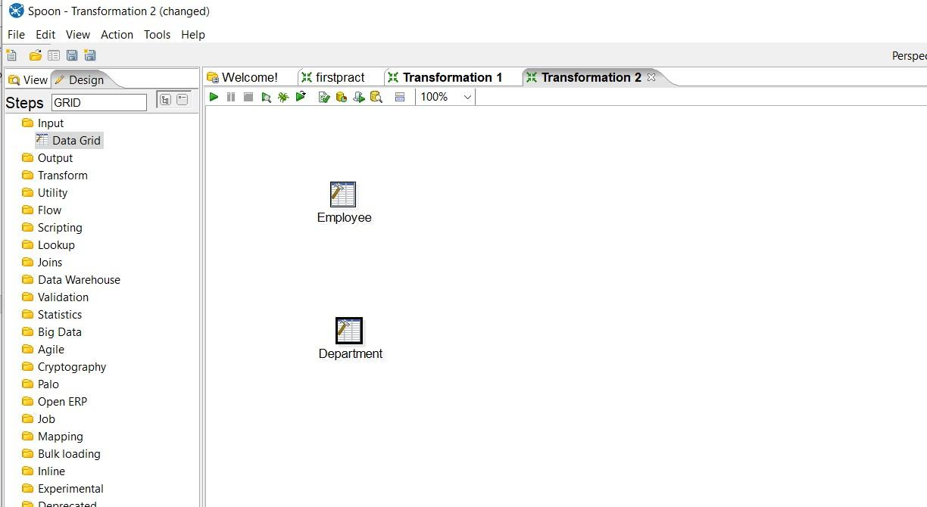

Step2: Insert Records into respective grids.

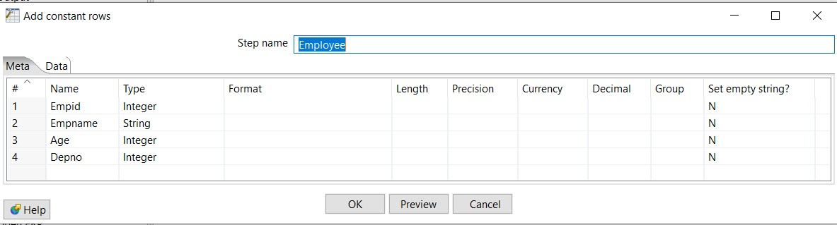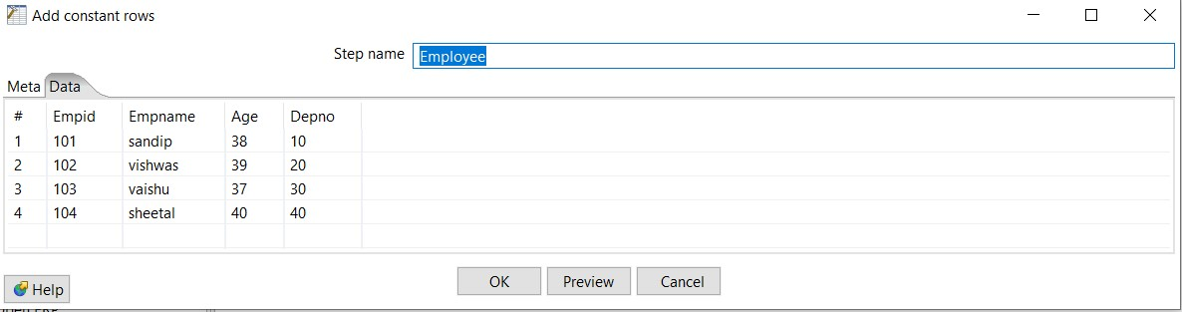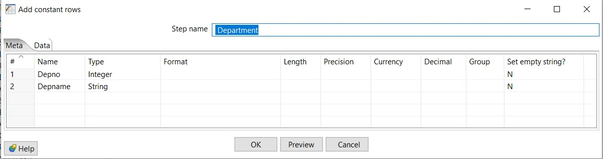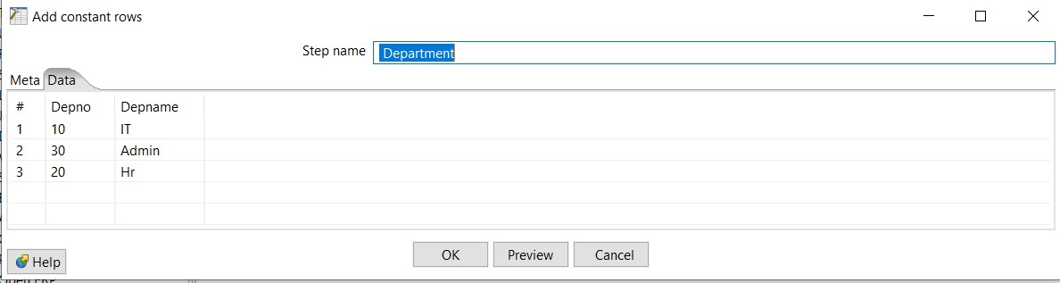

Step3: Insert sort rows transformation(on Empid) for both Employee and Department.

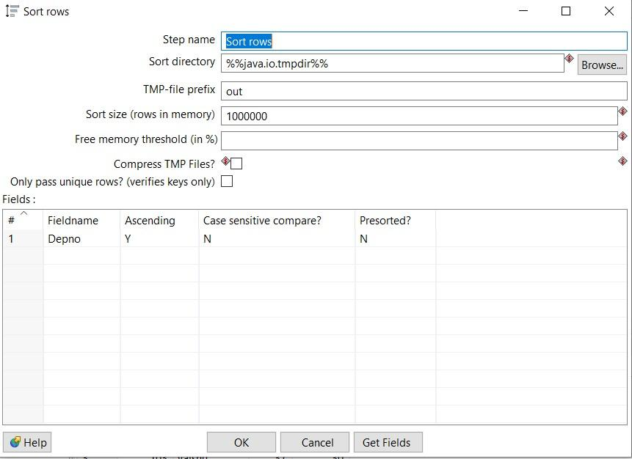

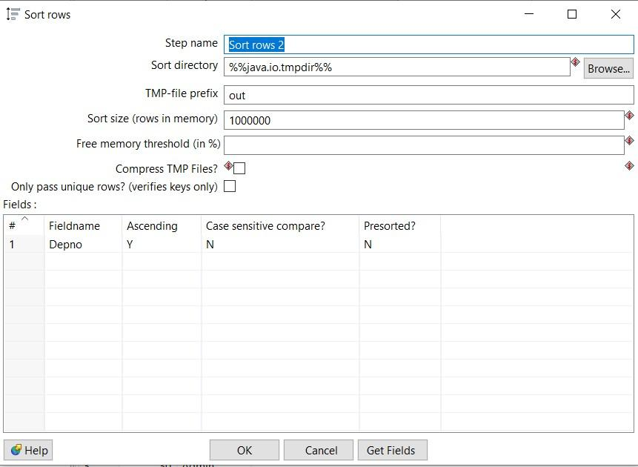

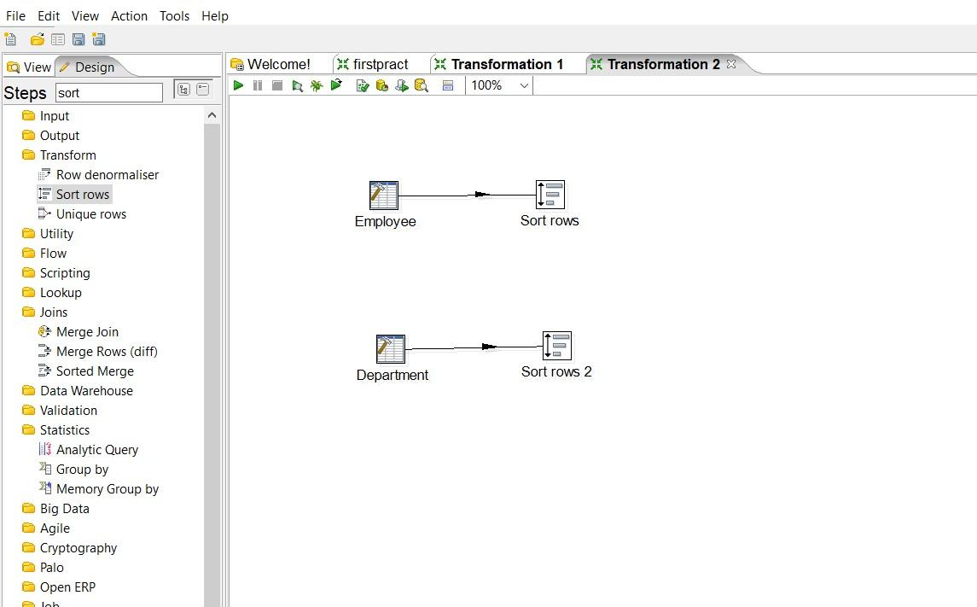

Step4: Add Merge join From Joins and connect it with sort rows.

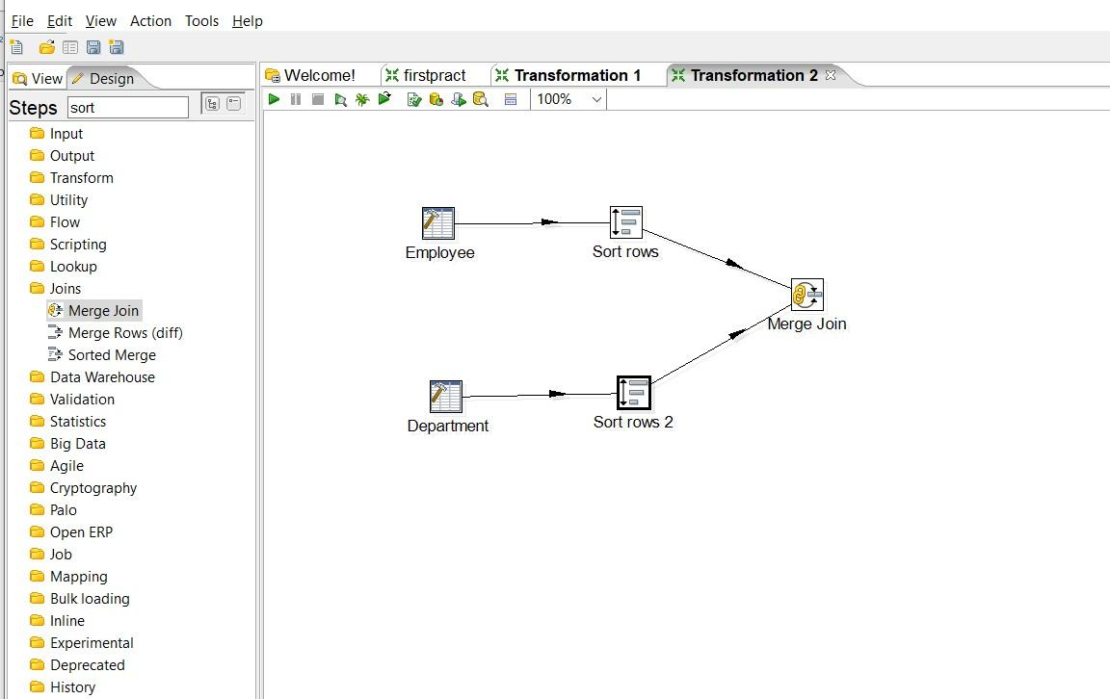

Step5: Double click on Merge join and made necessary settings First select First_step, then Second_step, select Join type INNER, and from get fields select Depno only, after that quick launch the transformation.

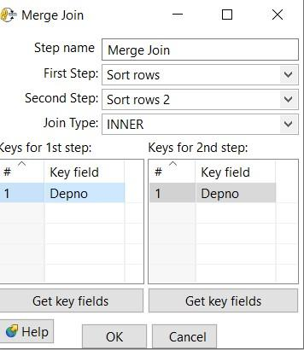

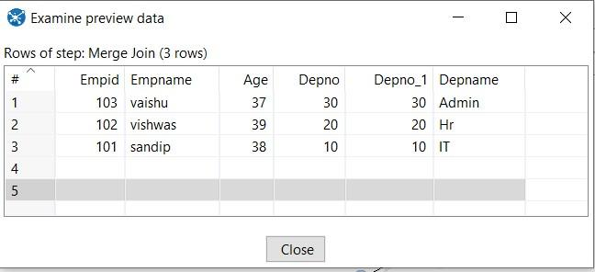

Step 6: Select Join Type Left Outer, then Right Outer and finally Full Outer join

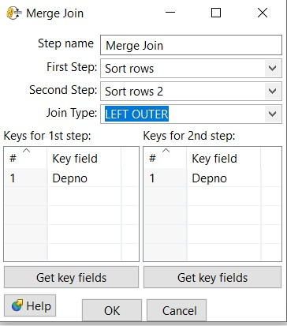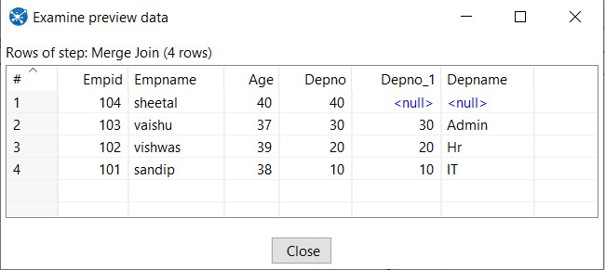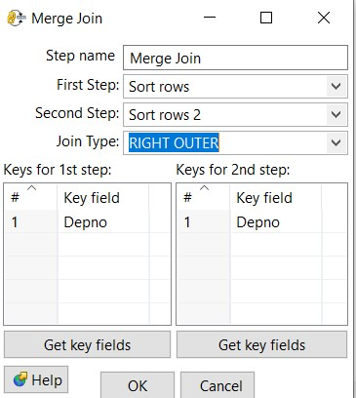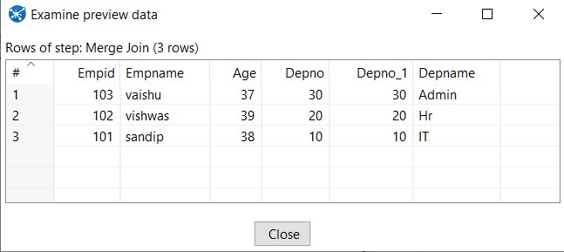

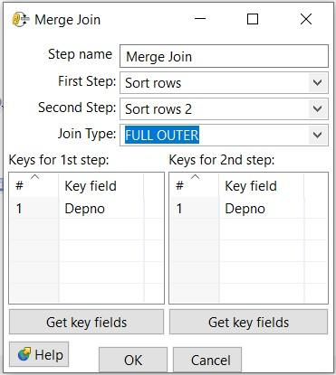

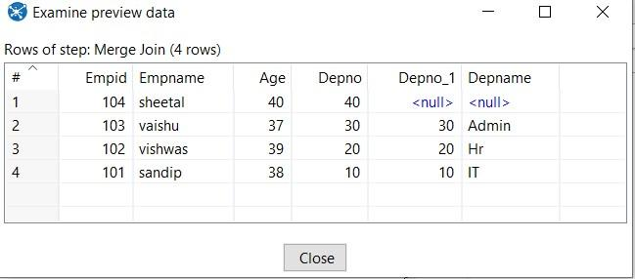

1. **Implement different data validations on table.** Step1: Drag and drop Data grid on panel.

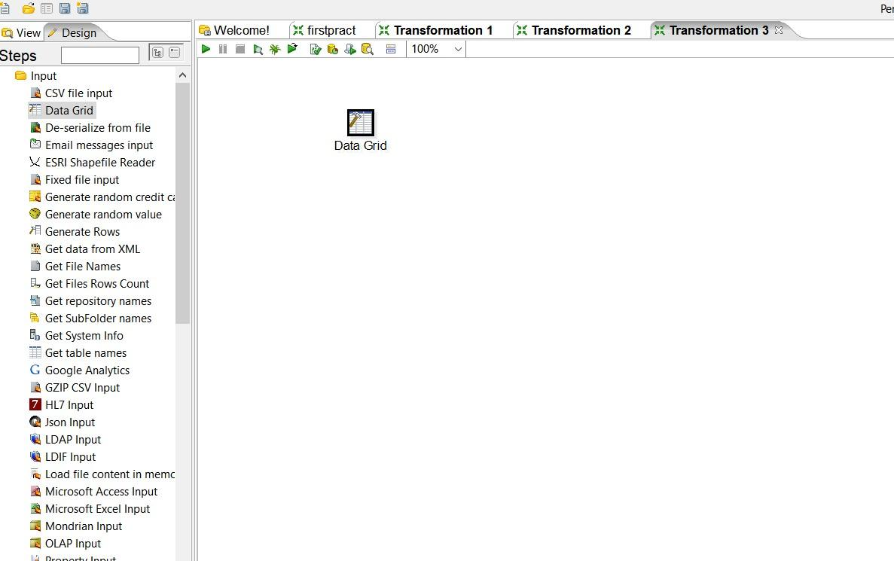

Step2: Double click on Data grid and create product table in Meta tab and enter records into it using Data tab.

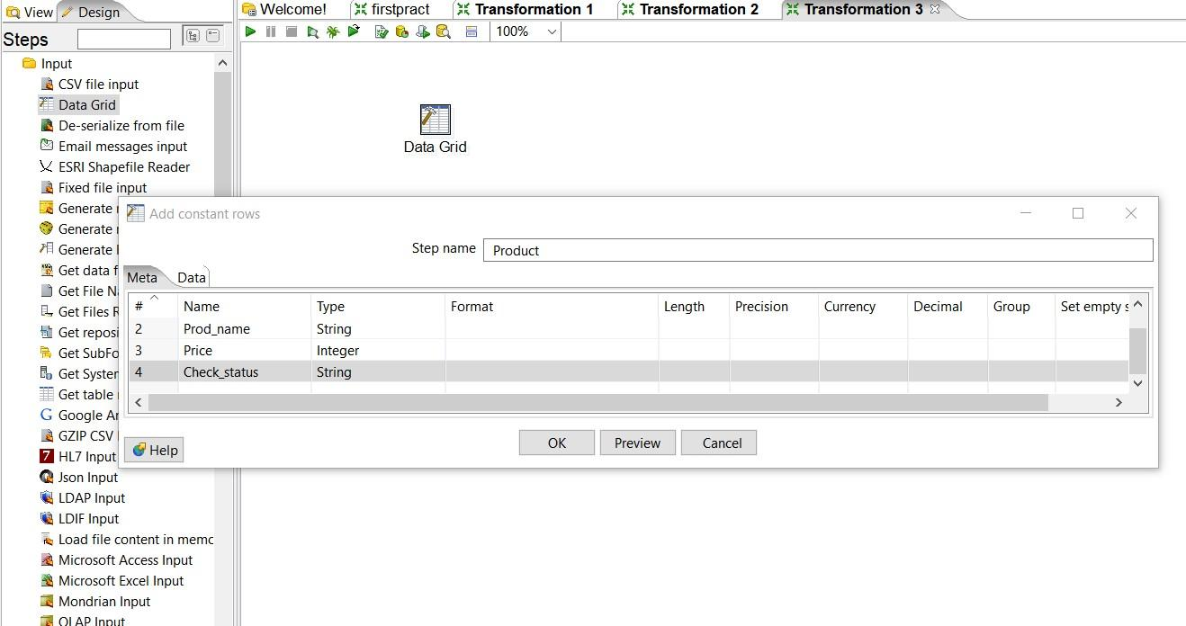

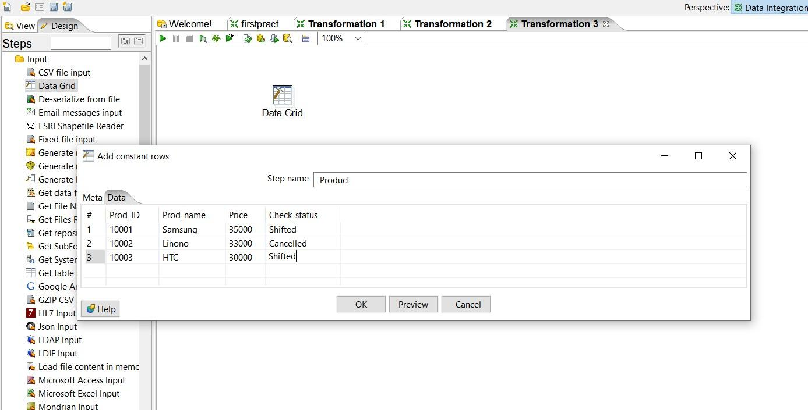

Step3: Go to Validation steps and select, Drag and Drop Data validator on panel and double click on it.

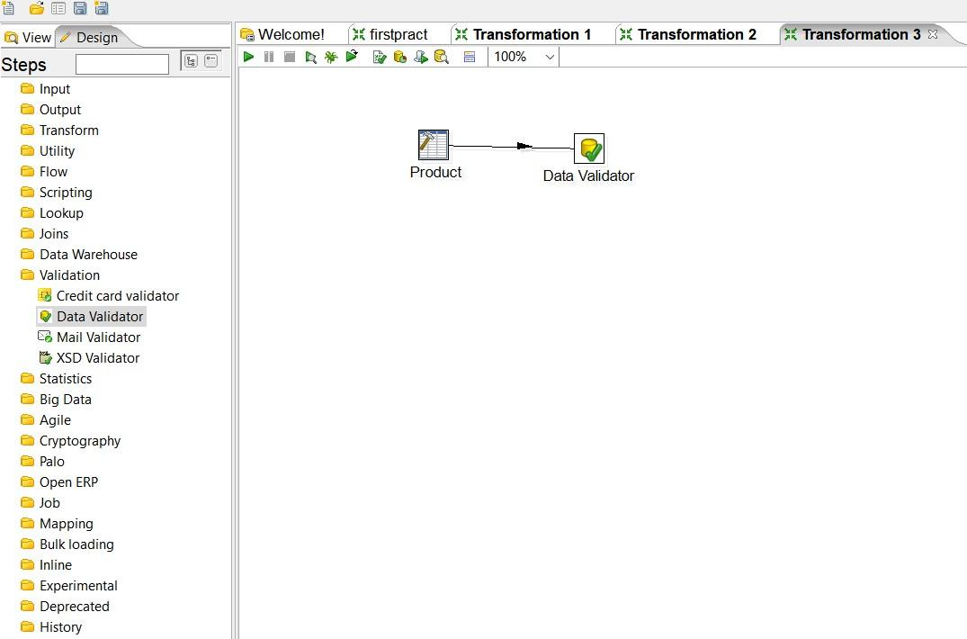

Step4: Click on new validation button and give new name to validation.

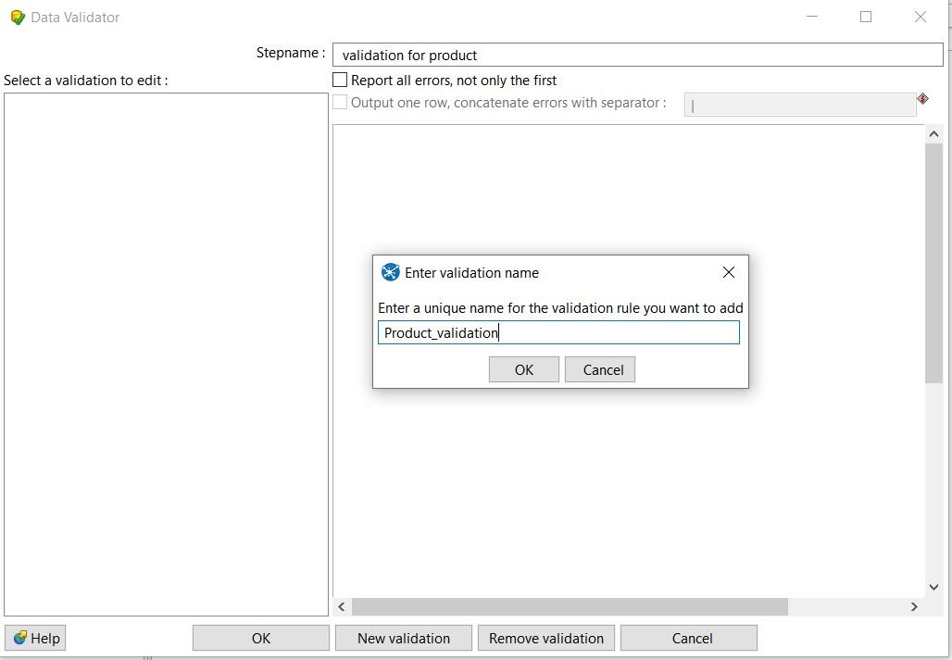Once new validation is created it will appear on left panel, double click on it to set data validation

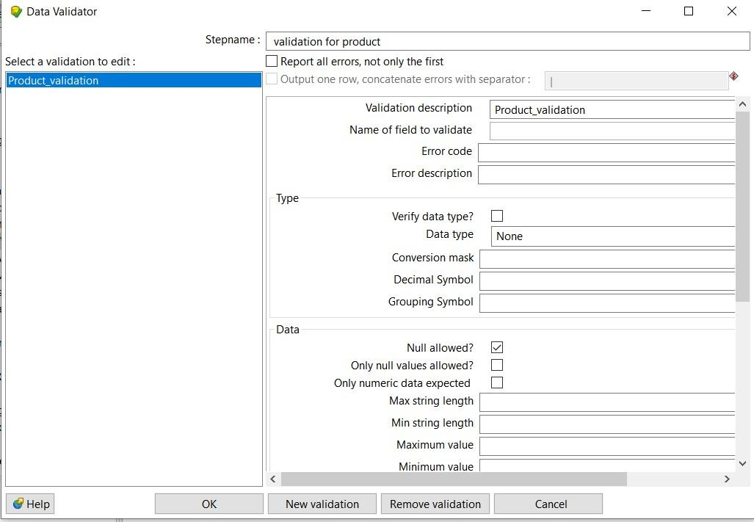

Step5: Set values for Name of field to validate=check status, and Data type =string

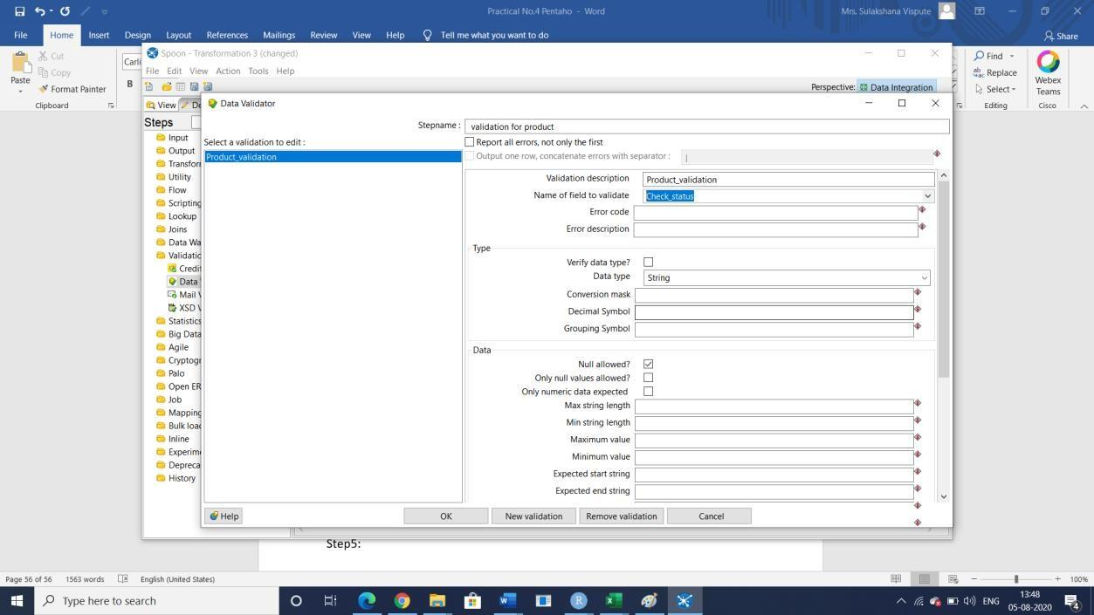

Step6: Click on add to set validation, set it65 to Shifted and press Enter and click on ok.

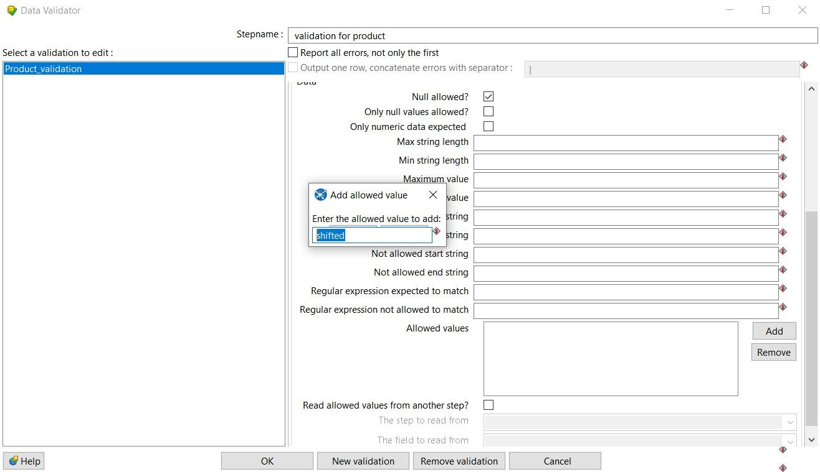

Step7: Select Dummy file from Flow to hold output and connect it with Data validation, while connecting select option “ Main Output of step”

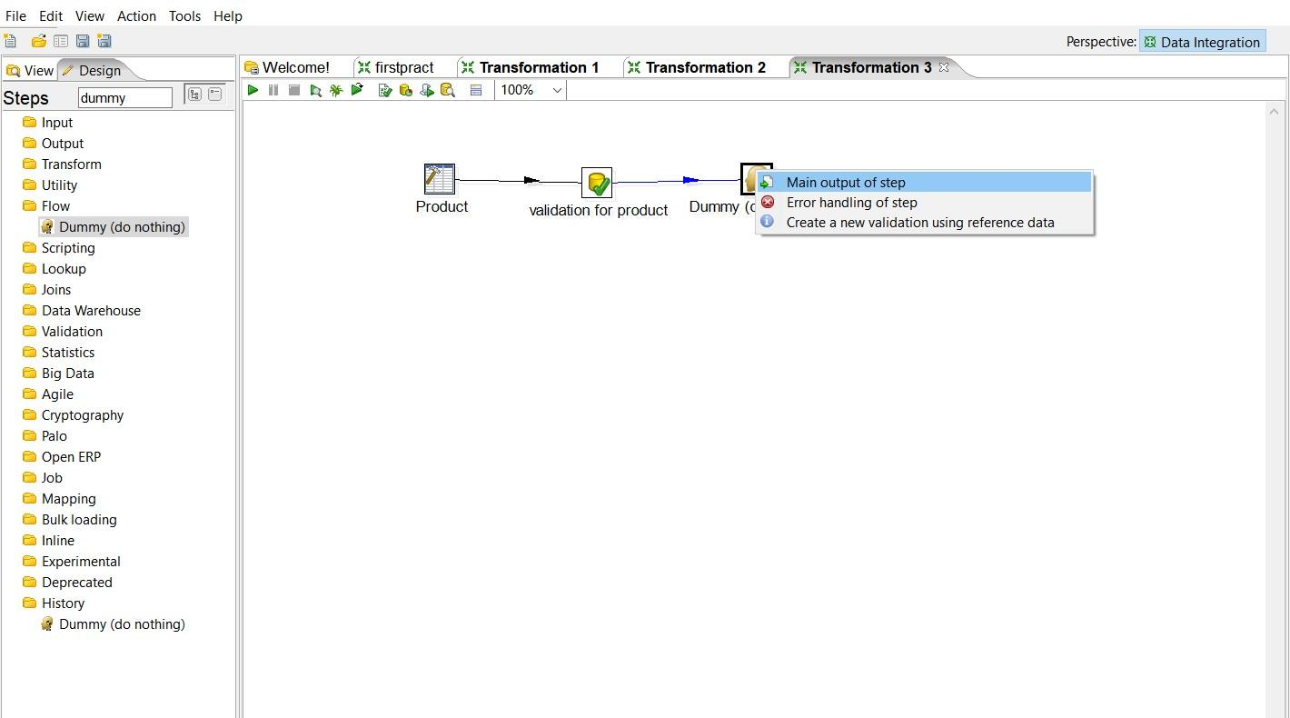

Step8: Select another dummy and connect it to ‘Validation for product’ and while selecting select ‘Error handling of step and in next window click on copy

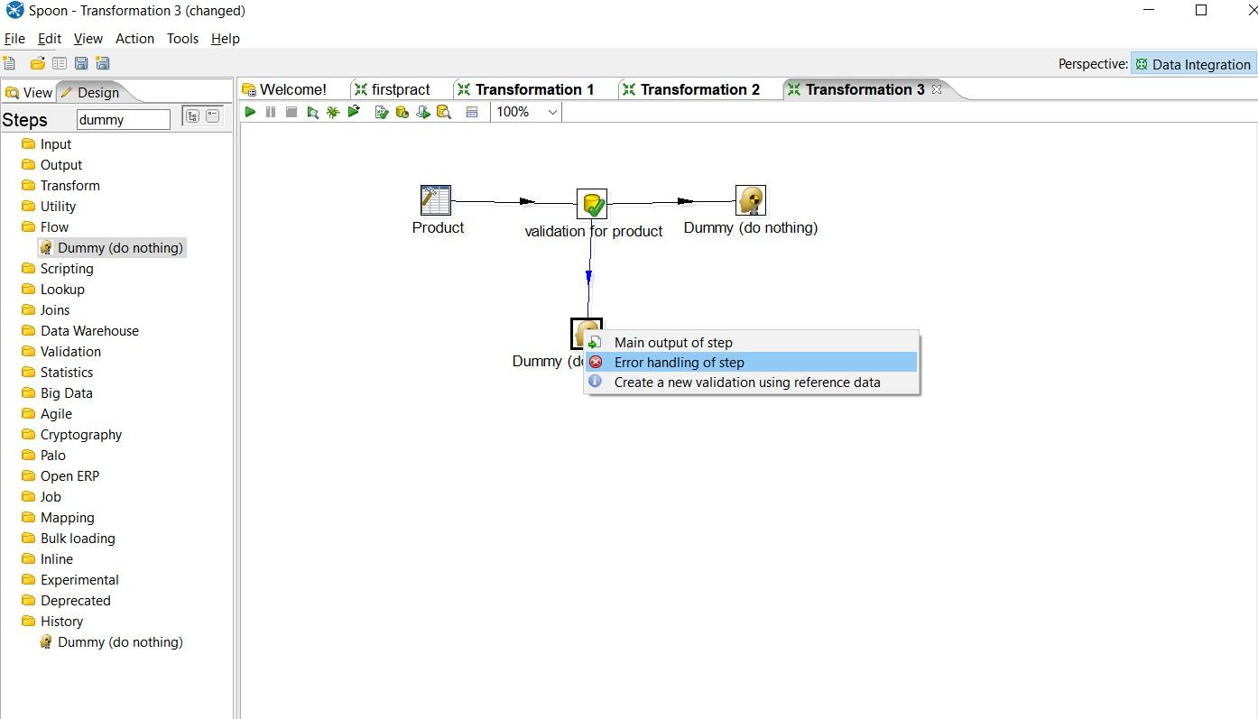

Step 9: launch transformation by selecting one dummy file each.

